 

**GEOINFORMATICS IN ASSESSING VULNERABLE ZONE FOR CORAL BLEACHING IN ANDAMAN, INDIA**

**Major Project work submitted for the fulfillment of the degree Bachelor of Technology in**

**GEOLOGICAL TECHNOLOGY AND GEOINFORMATICS**

*Submitted By*

*R. PRIYADHARSHAN (18MTGT23)*

Under the guidance of

**Dr. S. SARAVANAN**

Assistant Professor

Department of Civil Engineering

National Institute of Technology

Trichy-15

**Dr. K. PALANIVEL**

Professor

Department of Remote Sensing

Bharathidasan University

Trichy-23

**DEPAR**

**JUJUJU’**

**Jun- 2022**



**DEPARTMENT OF REMOTE SENSING**

BHARATHIDASAN UNIVERSITY

TRICHIRAPALLI

**BONAFIDE CERTIFICATE**

Certified that this project **GEOINFORMATICS IN ASSESSING VULNERABLE ZONE FOR CORAL BLEACHING IN ANDAMAN, INDIA** is a Bonafide work of **R. Priyadharshan** (18MTGT23)who all carried out the project work under our supervision for the partial fulfillments of the 6Year Integrated M.Tech Geological Technology and Geoinformatics programme. This is to further state that the work was not submitted earlier to any other institution for other degree or diploma.

**Internal Guide**

**Dr. K. Palanivel**

Professor,

Department of Remote Sensing,

Bharathidasan University,

Trichy-23.

**Head of Department**

**Dr. A. Balukkarasu**

Professor and Head,

Department of Remote Sensing,

Bharathidasan University,

Trichy-23.

**External Guide**

**Dr. S. Saravanan**

Assistant Professor,

Department of Civil Engineering,

National Institute of Technology,

Trichy-15.

**External Examiner**



**DEPARTMENT OF REMOTE SENSING**

BHARATHIDASAN UNIVERSITY

**TIRUCHIRAPPALLI-23**

**DECLARATION**

We hereby declare that the dissertation entitled **“GEOINFORMATICS IN ASSESSING VULNERABLE ZONE FOR CORAL BLEACHING IN ANDAMAN, INDIA”** has been carried out entirely by us under the guidance of **Dr.K.Palanivel** as our Major project of 6 years Intergrated M.Tech program in **GEOLOGICAL TECHNOLOGY AND GEOINFORMATICS** 4th Year 8th semester of Department of Remote Sensing, Bharathidasan University, Tiruchirappalli-23.

**R. Priyadharshan (18MTGT23)**

Place: **Tiruchirappalli**

Date**: 21/06/2022**

**ACKNOWLEDGEMENT:**

It is our great privilege to express our heartfelt gratitude and respect to all those who guided and inspired us to complete our project. We wish to express our deep sense of gratitude to our External and Internal guide’s Dr.S. Saravanan, Assistant Professor, Department of Civil Engineering, National Institute of Technology, Tiruchirapalli and Dr. K. Palanivel, Professor, Department of Remote Sensing, Bharathidasan University for his guidance and also for thoughtful suggestions, which helped us in completing the project on time. We also learnt a handful of knowledge through him.

We also thank Dr. A. Balukkarasu (Professor), Dr. C. Lakshumanan (Professor), Dr. D. Ramesh (Associate Professor), Dr. J. Saravanavel (Assistant Professor), and Dr. A. Muthamilselvan, Assistant Professor for helping us to carry out this project work.

We are very thankful to our scholars and our seniors for their timely

help and patience in supporting us to complete this project.

Above all we thank God and our parents for making this project successful with their support and encouragement. We thank them for giving us strength and moral support to pursue this training without any hindrance. We hereby record our sincere thanks to each and every one who helped in making out this project to submit on time without any delay.

This project cannot be completed without the effort and cooperation from our team members who was extremely helpful in each and every part of it.

Thanks to all.

Place: Tiruchirappalli

Date: 21.06.2022

# ABSTRACT:

The most conspicuous, rapid and destructive impact of global climate change on coral reef ecosystems is reflected by a physiological stress response of reef corals, a phenomenon called coral bleaching. The term coral bleaching is derived from the whitening of the tissue of reef corals that host endosymbiotic Symbiodinium microalgae (i.e., zooxanthellae). This whitening results from the expulsion of the zooxanthellae and/or the loss of photosynthetic, algal pigments, allowing the white aragonite skeleton to become visible through the transparent coral tissue. One of the major factor for coral bleaching is the increase in sea surface temperature which occurs mainly due to the global warming. Another most influencing factor is the salinity. With higher levels of rain, rivers will also have a higher runoff of water into the ocean decreasing the amount of salt. Another factor that can affect the salinity of the oceans is the melting of the polar ice caps, these factors reduces the salinity and salinity will increase the water will be acidified, the carbonic acid react to the lime or calcium carbonate so the Symbiodinium will be died or removed so the coral bleached. The chlorophyll-a concentration will intake the carbon dioxide so its reduce water acidification. Coral bleaching disrupts the mutualistic symbiosis between zooxanthellae and their cnidarian host, entailing the loss of an essential, internal photosynthetic energy transfer from the algal symbionts to the coral. At times, bleaching may be reversible, but rapid mortality of weakened and/or diseased corals is common with repetitive or intense events. In extreme instances, consequences for the functioning of coral reefs can be severely negative, as bleaching can lead to systemic failures and serious ecosystem degradation caused by usually irreversible phase shifts of benthic reef communities. Coral reefs are some of the most diverse and valuable ecosystems on Earth. Coral reefs support more species per unit area than any other marine environment, including about 4,000 species of fish, 800 species of hard corals and hundreds of other species. Data used in this case study are: MODIS, HYCOM and CIESIN data sets. The goal of the study is to identify coral bleaching occurred during 2005 to 2015 by using AHP model and MIF model which is expected to give proper result on the bleaching occurred. Using the AHP and MIF model the north side is less vulnerable and south side is more vulnerable because of the northern side is near to the pole and southern side is near to the equator, the major cause is el Nino. The SST, salinity will high and the chlorophyll-a concentration will be decreased. If Chlorophyll-a concentration is high the salinity will decrease so the wave action is low, the western side salinity is high so the wave action is high the coral bleaching vulnerability is high. And west side is covered by very low coral compare to eastern side. In 2005 the healthy coral is very less because of 2004 tsunami. Using the AHP model we identified Very healthy coral is 0.25%, healthy coral is 0.12%, moderately bleached coral is 0.18%, bleached corals is 71.77% and dead corals is 26.67%. Using MIF model we identified very healthy coral is 0.25%, healthy coral is 0.13%, moderately bleached coral is 3.75%, bleached coral is 61.74% and dead coral is 34.11%.

Table of Contents

ABSTRACT: 5

1. INTRODUCTION 9

1.1. General 9

1.1.2 Sea Surface Temperature 10

1.1.3 Salinity 11

1.1.4 Chlorophyll-A Concentration 12

1.1.5. The Importance of Coral Reefs 13

1.2. Aim 13

1.3. Objectives 13

2. LITERATURE REVIEW 14

3. STUDY AREA 18

3.1. Data sets and methodology 21

Table 1 – Data Used in this current study 22

4. METHODOLOGY 22

4.1. Analytic Hierarchy Process (AHP) modelling 22

4.2. Multi Influencing Factor (MIF) modelling 23

4.3. Data base generation 25

4.3.1. Sea Surface Temperature Map 25

4.3.2. Salinity Map 29

4.3.3. Chlorophyll-a Concentration 33

4.3.4. Bathymetry 37

4.3.5. Photosynthetically Available Radiation 37

4.3.6. Distance From Shore 39

4.3.7. Slope 40

4.3.8. Population Density 41

4.3.9. Existing Coral Cover 43

4.3.10. NDWI: 44

5. RESULT AND DISCUSSION 45

5.1. Integration of maps and preparation of final vulnerability map 45

5.3. MIF weightage 46

5.4. Overall weight and rank for both susceptibility models 47

5.4.1. Existing Coral Cover (ECC) 48

5.4.2. Population Density (PD) 49

5.4.3. Chlorophyll-a Concentration (CC) 49

5.4.4. Slope 49

5.4.5. Photosynthetically Available Radiation (PAR) 49

5.4.6. Distance From Shore (DFS) 50

5.4.7. Bathymetry 50

5.4.8. Sea Surface Temperature (SST) 50

5.4.9. Salinity 50

5.5.1. Susceptibility model-1 AHP 51

5.5.2. Susceptibility model 2 -MIF 58

**5.6. FUTURE PREDICTION FOR CORAL BLEACHING VULNERABLE ZONE** 65

6. CONCLUSION 68

7. REFERENCE 69

LIST OF TABLE

Table 1 AHP 51

Table 2 MIF 53

Table 3 Over all weights & rank for AHP & MIF 54

LIST OF FIGURE

Figure 1 12

Figure 2 13

Figure 3 location map 20

Figure 4 corals 21

Figure 6 Spatial variation SST for 2005 and 2006 26

Figure 7 spatial variation of SST for 2007, 2008,2009&2010 27

Figure 8 spatial varitation of SST for 2011,2012,2013 & 2014 28

Figure 9 spatial variation of SST for 2015 29

Figure 10 long term temporal variation of SST 29

Figure 11 spatial variation of salinity 2005 & 2006 30

Figure 12 spatial variation for salinity 2007 & 2008 31

Figure 13 spatial variation for salinity 2009 & 2010 31

Figure 14 spatial variation for salinity 2011 & 2012 32

Figure 15 spatial variation for salinity 2013 & 2014 32

Figure 16 spatial variation for salinity 2015 33

Figure 17 Long term spatial variation for salinity 33

Figure 18 spatial variation for Chlorophyll-a 2005 & 2006 34

Figure 19 spatial variation for chlorophyll-a 2007& 2008 35

Figure 20 spatial variation for chlorophyll-a 2009 & 2010 35

Figure 21 spatial variation for chlorophyll-a 2011 & 2012 36

Figure 22 spatial variation for chlorophyll-a 2013 & 2014 36

Figure 23 spatial variation for chlorophyll-a 2015 37

Figure 24 long term spatial variation for chlorophyll-a 37

Figure 25 spatial variation for bathymetry 38

Figure 26 spatial variation for PAR 2005 & 2010 39

Figure 27 spatial variation for PAR 2015 40

Figure 28 spatial variation for distance from shore 41

Figure 29 spatial variation for Slope 42

Figure 30 Population Density for 2005 & 2010 43

Figure 31 Population Density for 2015 43

Figure 32 Existing coral map for Andaman Islands 44

Figure 33 NDWI for Andaman region 45

Figure 34 spatial variation for SST & Bathymetry 52

Figure 35 spatial variation for Slope, salinity 52

Figure 36 spatial variation for PD&PAR 53

Figure 37 spatial variation for ECC& DFS 53

Figure 38 spatial variation for Chlorophyll-a 54

Figure 39 Vulnerability index map using AHP 2005 55

Figure 40 vulnerability index map using AHP 2010 56

Figure 41 vulnerability index map using AHP 2015 57

Figure 42 Vulnerability Index map using AHP 58

Figure 43 spatial variation for Slope &SST 59

Figure 44 spatial variation for Salinity& PAR 59

Figure 45 spatial variation for PD& chlorophyll-a 60

Figure 46 spatial variation for Bathymetry & DFS 60

Figure 47 Existing coral cover for Andaman region 61

Figure 48 vulnerability index map using MIF 2005 62

Figure 49 vulnerability index map using MIF 2010 63

Figure 50 vulnerability index map using MIF 2015 64

Figure 51 vulnerability index map using MIF 65

Figure 52 comparison of AHP & MIF model results 66

Figure 53 Future prediction map for 2045 using AHP 67

Figure 54 Future prediction map for 2045 using MIF 68

# 1. INTRODUCTION

## 1.1. General

Coral bleaching is a dynamic process that includes multiple levels of systemic causes and effects. Interactions of the environment at multiple spatial and temporal scales affect coral reef systems. Coral bleaching can be effective as an indicator of large-scale, exogenous environmental processes, or alternatively, there can be indicators of bleaching at the level of the organism up to the ecosystem indicating endogenous processes. Likewise, there can be temporal processes at the scale of the organism or ecosystem that allow differing indications of bleaching cause and effect. Corals have been an important structural feature of reefs in shallow tropical. They are highly productive and biologically diverse. Although coral reefs are geographically restricted to tropical seas and their occurrence limited to 0.2% of the ocean area on the earth's surface. Coral reefs have the potentiality to help lots of other biological creatures for the preparation of their community structure in a well developed way with the coral reef community. The productivity of healthy coral reefs sustains a rich interlinked network of species which has been the main source of food and resources for many tropical coastal and island people since the time of the first humans. Over the past three decades, a decline in reef coral abundance and diversity has been observed globally due to anthropogenic and natural causes. The ability of coral reef ecosystems to exist in balanced harmony with other naturally occurring competing/limiting physico-chemical and biological agents has been severely challenged in the last several decades by the dramatically increased negative and synergistic impacts from poorly managed anthropogenic activities.

The primary environmental factor triggering coral bleaching is elevated water temperatures, which cause physiological thermal stress. Extreme levels of solar irradiance, including visible and ultraviolet radiation, can create additional physiological stress to increase the deleterious impact of thermal bleaching. Furthermore, coral bleaching can result from a range of abiotic and biotic stressors as a product of their typical coastal, shallow water distribution. Often, many stressors act in concert to increase susceptibility of corals to thermal bleaching further by lowering their temperature threshold and, subsequently, exacerbating the degree of coral mortality. Considering the main environmental factors that induce reef corals to bleach (temperature and light), the stability of the coral-zooxanthellae symbiosis can serve as a sensitive environmental indicator, in particular, for temperature anomalies, which are included in climate change projections. Because corals often live in environments where temperatures are close to their physiological thermal threshold, they are highly vulnerable to bleach at temperatures 1degree C above the historical mean summer maximum in many regions. Satellite sea surface temperature data have shown that bleaching of variable severity can be expected if this warming persists for several weeks or increases, and this correlation is now used to forecast the global spatiotemporal distribution and intensity of coral bleaching events. Given the low thermal tolerance of many reef coral taxa, temperature anomalies can trigger widespread bleaching events posing serious threat to coral reefs world-wide.

Coral bleaching has a variety of causes. It may result from increases in [seawater](https://www.britannica.com/science/seawater) temperature, particularly when associated with elevated levels of solar irradiance (e.g., [ultraviolet radiation](https://www.britannica.com/science/ultraviolet-radiation)), or it may be caused by changes in seawater chemistry (e.g., due to [ocean acidification](https://www.britannica.com/science/ocean-acidification) or [pollution](https://www.britannica.com/science/pollution-environment)), increased levels of sediment in seawater, or a coral’s exposure to sodium cyanide (a chemical used in the capture of [coral reef](https://www.britannica.com/science/coral-reef) [fish](https://www.britannica.com/animal/fish)). Under such conditions the zooxanthellae may lose substantial amounts of their photosynthetic pigmentation, which decreases rates of [photosynthesis](https://www.britannica.com/science/photosynthesis) and produces bleaching. In addition, studies have found that the chemicals in [sunscreens](https://www.britannica.com/science/sunscreen) and other personal care products can [accumulate](https://www.britannica.com/dictionary/accumulate) in areas with significant marine tourism and recreational use by humans and can promote viral infections in hard corals that lead to bleaching. Exposure to increased temperatures and solar irradiance also causes zooxanthellae to manufacture abnormally large quantities of reactive oxygen species (molecules that contain [oxygen](https://www.britannica.com/science/oxygen) and at least one unpaired [electron](https://www.britannica.com/science/electron)), which are toxic to both the algae and their coral symbionts.

# 1.1.2 Sea Surface Temperature

High or largely fluctuating sea water temperatures can cause heat stress leading to expulsion of the zooxanthellae in an event known as coral bleaching; if the event is prolonged corals will degrade and die. The main cause of coral bleaching today is rising temperatures due to global warming. Bleached corals do not die immediately, but if the temperature is very hot, or too warm for a sustained period of time, they will die from hunger or disease. Warm-water coral reefs have declined by at least 50% over the past 30–50 years in large parts of the world’s tropical regions. Under a moderate greenhouse gas emissions scenario (RCP 4.5) it is likely that most coral reefs will disappear during the period 2040–2050.

The bay receives more rainfall; it also receives more freshwater from the large rivers, especially the Ganga and the Brahmaputra, that empty into it. This freshens the surface of the bay and stabilizes the water column, making it more difficult for the winds to mix the warm, stable surface layer with the cooler waters below. In the Arabian Sea, there is no such stabilizing effect. As a consequence, the mixing with the cooler waters below is more vigorous. Since a sea surface temperature of about 28ºC is necessary for convection to take place in the atmosphere, this condition is satisfied in the Bay of Bengal but not in much of the Arabian Sea. Thus, in spite of their geographical similarities, the two arms of the north Indian Ocean are strikingly different when it comes to climate.

**El Niño Phenomenon**

A more easily observable that occurs example of the ocean's role in climate is El Niño, a phenomenon that occurs in the equatorial Pacific Ocean. When an El Niño occurs, the waters off Peru warm, and these warm waters spread westward, increasing the sea surface temperature across the eastern and central Pacific. This suppresses convection over Indonesia and the western Pacific. The effect of El Niño is not restricted to the equatorial Pacific. The large expanse of the basin, which covers almost half the globe, ensures that El Niño has a global impact on climate. During El Niño, with the atmospheric convection over the western Pacific being suppressed and the band of high rainfall shifting eastward, there is a tendency for rainfall over India also to decrease.

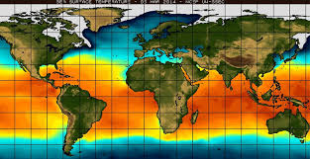

Figure 1

# 1.1.3 Salinity

Reduced salinity in the water has been found to be a major leading factor of Coral Bleaching. This process is believed to happen due to the fact that corals are "osmoconformers." This means that corals will gain or lose water to try and keep an isotonic environment around them. This means that when water with low salinity comes near the coral, this organism will intake water to reduce its salt concentration. This process will end up reducing the amount of “symbiotic dinoflagellates from host tissues” causing the coral bleaching.

There are several factors that can affect the salt concentration in the oceans. One factor that has been linked with reduced salinity is increased rain fall in cost areas. With higher levels of rain, rivers will also have a higher runoff of water into the ocean decreasing the amount of salt. Another factor that can affect the salinity of the oceans is the melting of the polar ice caps. It has been found that water with higher salt concentration will move to warmer areas, while low salt concentration will lay near cold water. This means that corals that are located near tropical areas will exhibit higher salinity, while those coral that lie closer to colder water lower salinity.

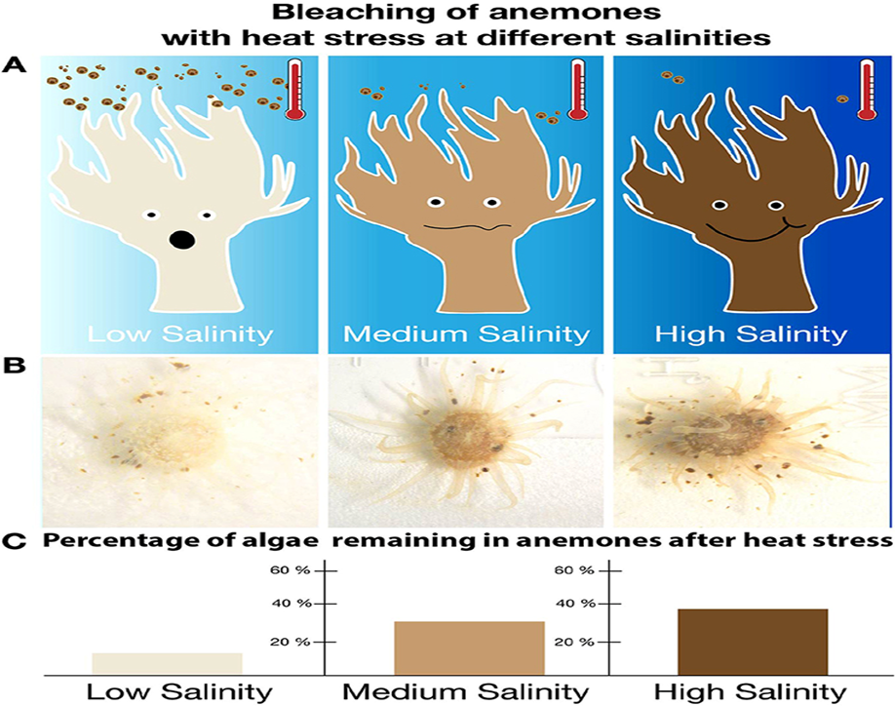

Figure 2

# 1.1.4 Chlorophyll-A Concentration

Chlorophyll-A is a green pigment found in plants. It absorbs sunlight and converts it to sugar during photosynthesis. Chlorophyll a concentrations are an indicator of phytoplankton abundance and biomass in coastal and estuarine waters. They can be an effective measure of trophic status, are potential indicators of maximum photosynthetic rate (P-max)2 and are a commonly used measure of water quality. High levels often indicate poor water quality and low levels often suggest good conditions.

It is natural for chlorophyll *a* levels to fluctuate over time. Chlorophyll *a* concentrations are often higher after rainfall, particularly if the rain has flushed [nutrients](https://ozcoasts.org.au/indicators/biophysical-indicators/water_column_nutrients/) into the water. Higher chlorophyll *a* levels are also common during the summer months when [water temperatures](https://ozcoasts.org.au/indicators/biophysical-indicators/temperature/) and light levels. Tidal regime is an important control on algal [biomass](https://ozcoasts.org.au/glossary/biomass/). Strong tidal mixing lowers chlorophyll *a* concentrations because the [residence time](https://ozcoasts.org.au/glossary/residence-time/) of algae in the photic zone is reduced. Tidal mixing also causes [fine sediment](https://ozcoasts.org.au/glossary/fine-sediment/) to resuspend, and the elevated [turbidity](https://ozcoasts.org.au/indicators/biophysical-indicators/turbidity/) levels that result reduce the amount of light available for [photosynthesis](https://ozcoasts.org.au/glossary/photosynthesis/).

# 1.1.5. The Importance of Coral Reefs

Coral reefs are some of the most diverse and valuable ecosystems on Earth. Coral reefs support more species per unit area than any other marine environment, including about 4,000 species of fish, 800 species of hard corals and hundreds of other species. Scientists estimate that there may be millions of undiscovered species of organisms living in and around reefs. This biodiversity is considered key to finding new medicines for the 21st century. Many drugs are now being developed from coral reef animals and plants as possible cures for cancer, arthritis, human bacterial infections, viruses, and other diseases.

Healthy coral reefs support commercial and subsistence fisheries as well as jobs and businesses through tourism and recreation. Approximately half of all federally managed fisheries depend on coral reefs and related habitats for a portion of their life cycles. Coral reef structures also buffer shorelines against 97 percent of the energy from waves, storms, and floods, helping to prevent loss of life, property damage, and erosion. When reefs are damaged or destroyed, the absence of this natural barrier can increase the damage to coastal communities from normal wave action and violent storms.

# 1.2. Aim

To map the bleached and dead corals using Remote Sensing in Andaman Island and to assess causative parameters for coral bleaching in Andaman Islands using **Analytic Hierarchy Process (AHP)** method and **Multi Influencing Factor (MIF)** method through GIS techniques.

# 1.3. Objectives

1. To study the coral bleaching susceptibility using AHP & MIF techniques using Remote Sensing and GIS.
2. Generation of Geospatial database on SST, salinity, solar radiation at PAR, chlorophyll concentration, existing coral cover, distance from shore, bathymetry, slope and population density.
3. To estimate the amount of coral bleached during 2005 – 2015
4. To identify future coral bleaching susceptibility using the CA Markov algorithm.

## 2. LITERATURE REVIEW

**A Study on the Delineation of Coral Reefs in Andaman and Lakshadweep Islands Using RISAT-1 Data**

Thara Nair • Latha James • C. V. Rao • A. V. V. Prasad • B. Gopala Krishna • V. K. Dadhwal

This study explores the possibility of utilizing synthetic aperture radar (SAR) data of Radar Imaging Satellite-I, India’s first indigenous microwave satellite to delineate the coral reefs in Andaman and Lakshadweep Islands in the Indian Ocean. Coral reef mapping using optical and SAR data provides a mutually supporting platform. Tropical regions being the prominent habitat for coral reefs, which are very frequently cloudy, SAR can specifically contribute in mapping coral reefs, due to its all-weather/day night capability. Under favourable imaging conditions, SAR is capable of mapping entire regime of shallow reefs with very good classification accuracy. SAR has a performance comparable with passive optical sensors under favourable conditions of imaging, viz. optimum tidal current and surface winds. The study results are compared with the international coral reef reference map and are found to be highly promising, with an overall accuracy of 98.3% and a Kappa coefficient of 0.944 for fringing reefs in Andaman region. This study tries to explore a different horizon for microwave remote sensing in coral reef studies. It is seen that, optical and microwave remote sensing can provide a mutually supporting platform in coral reef delineation, in terms of imaging depth as well as climatic conditions. This study tries to highlight the fact that optical and microwave remote sensing can provide a mutually supporting platform in coral reef delineation.

**On the Recurrence of Coral Bleaching and Recovery in North Bay, Port Blair, Andaman and Nicobar Islands**

G. Dharani, A.K. Abdul Nazar, N. Saravanane, N.V. Vinithkumar, J. Santhanakumar, Krupa Ratnam, Dilip Kumar Jha, D. Magesh Peter, P. Venkateshwaran, T.S. Kumar, and R. Kirubagaran

Coral cover, live-form categories, bleaching and their recovery were monitored in North Bay, South Andaman during pre- and post-tsunami periods. The reef is a fringing type, with a total coral cover of 313,382 m2. The total live and dead coral percentages recorded prior to tsunami were 29.4% and 27%, respectively. A patchy bleaching of 7.5% was recorded in month of April–May 2005. However, the coral reef started to recover quickly, and as much as 4.7% of recovery was recorded, and 2.8% of the bleached coral failed to recover. No significant variations in the physicochemical parameters were recorded prior to and post tsunami. The physicochemical parameters of the seawater in the coral reef environment (North Bay) were monitored during 2003–2005 covering pre- and post-tsunami periods following standard methods. The atmospheric temperature and soar radiation were recorded by meteorological station installed in PMB tower. Coral cover in the North Bay area was mapped using high-resolution multispectral satellite image (P6 LISS4-MX) acquired on 11 February 2005. The image was enhanced with respect to multiple bands in ERDAS Imaging 8.7. Based on the field survey, visual interpretation was made on the satellite image, and the coral coverage was delineated on the screen. Thus, the created polygon is transferred to ARCGIS, and detailed map was prepared. The boundaries of the coral cover were checked in the field using DGPS. Patches of coral bleaching was recorded across the large group of genera, including soft coral and zooanthids inhabiting North Bay. North Bay is a fairly good fringing reef environment which is directly exposed to Andaman Sea; the reef is dominated by Porites lutea, Porites nigrescens and Acropora sp. The total reef area is approximately 313,382 m2 ; dead coral, coral rubbles and coral sand constitute about 170,241 m2. The total live and dead coral percentages recorded prior to tsunami were 29.4% and 27.0%, respectively, and the live coral cover reduced to 21.5 after 2004.

**Status of Coral Reefs in Post-Tsunami Period in Andaman & Nicobar Islands**

Saxena. A , R. Rajan & S. S. Choudhury

The survey done by Kulkarni and Saxena (2002) for 24 coral reef sites identified under a coral reef monitoring action plan showed the distribution, status of health and mortality of corals. The Tsunami that struck these islands on 26th December 2004 led to vast destruction of coral reefs mainly due to geo-morphological changes resulting in uplifting and exposure of reefs in the northern islands and submergence in the southern islands A rapid assessment done by the NGO Reef Watch in 2005 showed that there was overall 20% mortality in Andaman group of Islands while in Nicobar group of Islands, up to 80% mortality was observed. The present study is based on the survey being carried out at different coral reef sites to monitor the recovery processes. The initial results show not only recovery but also changes in the distribution pattern of corals. The survey methods used included LIT (Linter Intercept Transect), Manto Tow and species diversity and area estimation in exposed reefs. The damage to coral reefs took place as a result of two events that occurred on 26th December 2004- the first one being the massive earthquake with intensity of 9.3 Richter scale causing geomorphological changes in these Islands. The second was in the form of a giant tsunami wave. The earthquake resulted into uplifting of land by more than 1 m in the North and Middle Andamans and subsidence of land by more than 1 m in the Nicobar group of Islands. This led to exposure of reefs in the northern Islands of the Andamans where mortality ensued due to exposure of reefs while in the Nicobar group of Islands the damage was due to wave action. Many corals were uprooted, broken and turned upside down. Moreover, a lot of sediments was mobilized by wave action and currents, leading to smothering of corals.

**Status of coral reefs in Andaman after two major catastrophic events - tsunami of December 2004 and bleaching of May 2005**

S. Dam Roy, Grinson-George, R. Soundararajan, P. Krishnan, S. Murugesan and M. Kaliyamoorthy. Fisheries Science Division, Central Agricultural Research Institute, Port Blair, India

The surveys were carried out in two phases at Mahatma Gandhi Marine National Park (MGMNP), Wandoor covering two islands viz., Jolly Buoy and Tarmugli; Rani Jhansi Marine National Park, Havelock covering three sites viz., Bipuldera, lighthouse and Havelock jetty of South Andaman by snorkelling and free diving and so were essentially confined to the reef flats. Phase I was preliminary survey in which the investigators swam over the reef area to make observations which were qualitative in nature. Phase II consisted of detailed quantitative observations using Line Intercept Transect (LIT) survey method. Further, the exposed reefs were visually verified at North Andaman. Three parallel transects, 50 m apart, were initially laid out at reef flat, reef edge and reef slope. Observations were made for every for all the biotic and abiotic elements. The mean values of data collected from the three transects were used for all computations for each station. The massive coral bleaching during May, 2005 was mainly due to the elevation of sea surface temperature (SST) resulting in separation of the symbiotic algae from host corals, which play key role in supplying synthesized food to the host corals. SST was ranging from 31.5 to 32 o C during May-June 2005. Observations were made on mass bleaching of corals and associated fauna. This was in par with the 1998-bleaching incident. This comparative study reveals the similarities and variations in the bleaching events of both years.

**Implications for Conservation of Coral Reefs in the Andaman and Nicobar Islands, India**

R. Jeyabaskaran , K. Venkataraman and J.R.B. Alfred

The Indian Ocean tsunami on December 26, 2004 caused severe damage to coral reefs of these Islands. About 4000 ha of North Andaman, 1211 ha of South Andaman and 3500 ha of Nicobar Island reefs were damaged due to tsunami. The tribal people of Nicobar Islands are exempted from the wildlife act and it cause extensive damage to coral reef associated fauna. Nowadays poaching and tourism developments are the major threats to reefs. There are 1,10,000 tourists are visiting the islands during the calm weather season from October to February. Paddy field of these Islands covers about 10,517 ha with the usage of 32 kg fertilizers per hectare. Fertilizers discharges into sea cause algal over growth on reefs. Tourism: Tourist’s number has been increasing in every year and their interest is towards the Islands with clean beaches and healthy corals. About 1,10,000 tourists are visiting the Islands including nearly 5,000 foreigners during the period of calm weather season from October to February. The coral reefs of Jolly Buoy, Redskin and North Bay Islands of Andaman have severely been damaged by the tourists. As foreign tourists not many, the current problems arising out of uncontrolled tourism in the Islands pertained to Indian tourists. Poaching: Poaching is peculiar and a serious problem in the Andaman & Nicobar Islands. About 184 fishing boats were apprehended during the last one decade. There are two basic types of poaching activities prevailing in the A & N region i.e. poachers coming from neighboring countries mainly from Myanmar in small dinghies (boats) to the coast for collecting marine wealth and poaching by modern mechanized trawlers of neighboring countries particularly from Thailand and Indonesia in the Exclusive Economic Zones (EEZ). There is an urgent need for evolving effective management to protect the coral reefs. To prevent coral bleaching few research and precaution like permanent monitoring site should be established in each reef to study the patterns of recovery and changes in reef structure. Mapping of coral reef resources using remote sensing and GIS techniques. Assess the physiological status of coral reefs using molecular biomarker system. Nowadays corals are also affected by different kind of diseases too.

Based on the above literature review, the followings research objectives are developed for this present study. No such studies were already reported using these methodologies (AHP &MIF) for assessing Coral Bleaching Susceptibility (CBS) in the area of Andaman Island.

### 3. STUDY AREA

The Andaman and Nicobar group of islands is bounded by Bay of Bengal in the west and Andaman Sea in the east, with a total land area and a coastline stretch of 8249 km2 and 1962 km respectively, and consists of 345 islands (fig.1). The Andaman Islands are divided into North Andaman, Middle Andaman, and South Andaman by the Andaman ridge. Spanning over 6 ◦45′N to 13◦41′N and 92◦12′E to 93◦57′E the archipelago is one of the key biodiversity regions of the world, fringed spectacular coral reefs and extensive mangrove forests. Characterized with a typical tropical climate, these islands witness heavy cyclones, hot and humid weather conditions all-round the year. The daily temperature ranges from 27 ◦C to 38 ◦C in the summer and 21 ◦C to 25 ◦C in the winter and relative humidity in the atmosphere reaches to about 80%. The North East monsoon arrives in November followed by the South West monsoon towards the end of May. According to the Rainfall Statistics 2016 of the Indian Meteorological Department (IMD), North Andaman received an average annual rainfall of ≈2420 mm and South Andaman received an average annual rainfall of ≈3295 mm and the entire Andaman Nicobar Island received 2852 mm of average annual rainfall.

The Andaman Island is located to the north-west of the central part of Coral Triangle, an area enclosed by Philippines central and eastern Indonesia and northern and eastern Papua New Guinea. With a total reef area of 948.8 km2, this island has a rich coral diversity with as many as 235 species of hard corals and 111 species of soft corals. The western coastlines of the Andaman and Nicobar Islands are fringed by coral shelves 10–50 km wide and have little indentation and few coastal plains, only on the shores in contrast to eastern parts, which are more indented and steep.

In the Andaman, the reef flat extends seaward up to about 500 m from shore (fig.2). Often the reefs merge with submerged reefs towards the sea in places like Wandoor National Park, mainly around Tarmugli Island, in the eastern part of Middle Andaman, around North Reef Island etc. In Boat Island, Jolly Bouy Island and North Sentinel Island, deeper reef flat has been recorded, whereas, muddy and sandy reef flats under coastal turbid environments have been observed near the mainland. 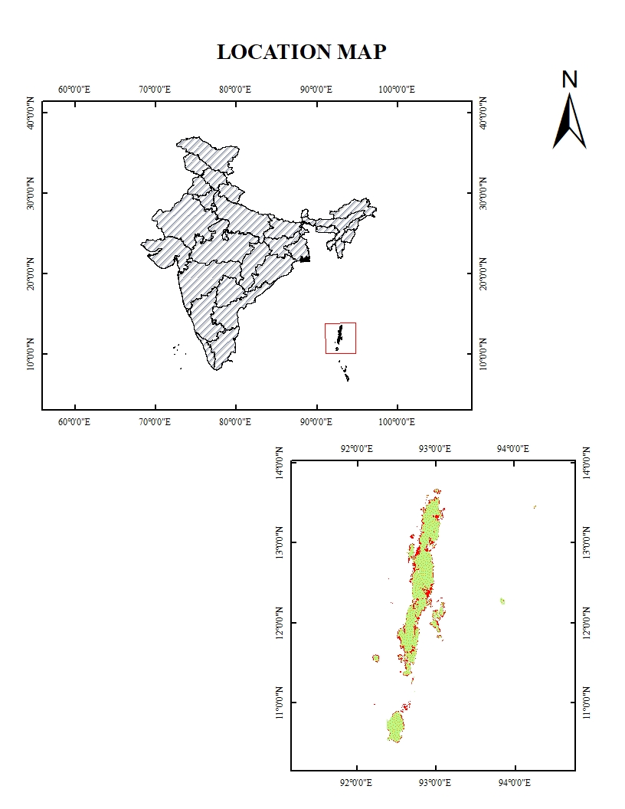

Figure 3 location map

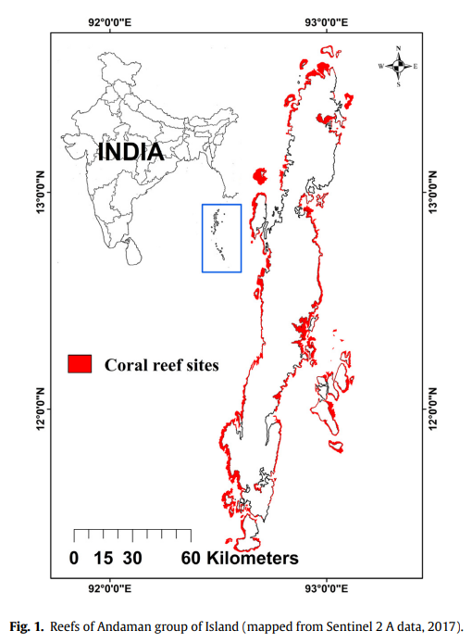

Figure 4 corals

### 3.1. Data sets and methodology

The accomplishment of the whole methodology is illustrated in the flowcharts, and the data which we have used is shown below. According to our study area, we need to consider certain criteria’s to suggest vulnerable zone for coral bleaching. In order to derive the bleaching vulnerable zone we need many layers which are spatial and nonspatial collection of data. Preparation of main parameter and the Additional Criteria maps were used. We prepared a land use and land cover map from Sentinel 2 , Sea Surface Temperature (SST) from NASA Ocean Color data ( MODIS -Aqua), Salinity from HYCOM (hybrid) , Chlorophyll-a concentration (CC) from NASA Ocean color data (MODIS-Aqua), Solar radiation at Photosynthetically Available Radiation (PAR) from NASA ocean color data (MODIS-Aqua), Existing Coral Cover (ECC) from Allen Coral Atlas (US), Population Density (PD) from CIESIN-GPW 411 ( Gridded Population of the World ), Bathymetry from HYCOM , Slope Power Change (SPC) from HYCOM, Distance From Shore (DFS) and Normalized Difference Water Index (NDWI) from LANDSAT-5 these data were collected from Google Earth Engine (GEE) for the year 2005 to 2015 at 4 m resolution and demarcated using ARCGIS and QGIS software. SST, Salinity, Bathymetry, PAR, Distance from Shore are the main parameters and the additional parameters are Slope power change, Chlorophyll_a concentration, Existing coral cover and population density, and NDWI. Further certain maps are preferably selected and assigned certain weightage values with accordance with selectable knowledge and guidance and then Integration of these layers are done by using Analytic Hierarchy Process (AHP) Model and Multi Influencing Factor (MIF) Model. Thus, by using the GIS software the layers are taken and processed as raster based model by assigning weightages to each of the features in the selected layers and the obtained map summarizes the vulnerable zone . In order to derive the vulnerable zone map we need many layers which are spatial and nonspatial collection of data.

## Table 1 – Data Used in this current study

|  |  |  |  |  |
| --- | --- | --- | --- | --- |
| **Sl. No** | **Satellite data** | **Date of Acquisition** | **Spatial Resolution** | **Sensor** |
| 1 | MODIS | 2005 - 2015 | 500m | Aqua |
| 2 | MODIS | 2005 - 2015 | 500m | SeaWIFS |
| 3 | HYCOM | 2005 - 2015 | 500m | Sea-Temp-Salinity |
| 4 | CIESIN | 2005 - 2015 | 500m | GPW |

Table 1 – Data Used

#### 4. METHODOLOGY

In this study we have used nine parameters. The main parameters are 1. Sea Surface Temperature (SST) 2.Salinity 3.Bathymetry 4.Photosynthetically Available Radiation (PAR) 5.Distance from Shore (DFS). The additional parameters are 1. Existing Coral Cover (ECC) 2.Population Density (PD) 3.Slope 4.Chlorophyll-A Concentration. We have used two methods namely AHP & MIF. We assigned the weightage for each layer for susceptibility models and using each methods separately we delineated the vulnerable zone for coral bleaching.

#### 4.1. Analytic Hierarchy Process (AHP) modelling

Multi-criteria decision-making technique is a widely used technique for suitability analysis, and AHP is one of them which is proposed by (Saaty, 1980); According to (Şener et al., 2011), it defined as extensive technology that integrates practical and subjective opinions of experts to complete decision-making by assessing several factors. In this method, each factor assigned rank on a scale of one (equal significance) to nine (extreme significance) by assessing each element based on the pairwise comparison. This analysis evaluates the importance of the parameter that influences vulnerability zone. The prepared layers are assigned weights derived by this technique and were subjected to weighted overlay analysis. In pair-wise comparison matrix, row follows the reciprocal value of each parameter and its importance with the second parameter. The generic pair-wise comparison matrix is made by normalizing pair comparison matrix. After that weights are estimated by arithmetic mean. The consistency index (CI) is estimated by the corresponding expressions (Eqs. (1) and (2)):

CR=CI/RI (1)

CI is consistency index, CR is consistency ratio, and RI is the random index,

CI = λ max−n/n−1 (2)

where n is the number of conditioning factors, and λ max is the principle eigenvalue of the matrix. RI value is directly taken from the (Saaty, 1980) research paper, which depends upon the number of components. The weights determined using the matrix is valid only when CR ≯0.1. Pairwise comparison matrix is shown in Table 2.

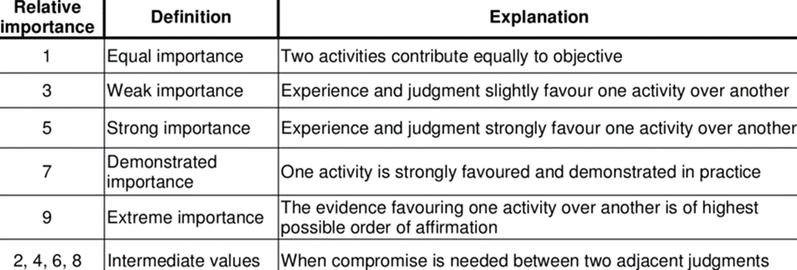

**AHP pairwise comparison table (Saaty 1980)**

#### 4.2. Multi Influencing Factor (MIF) modelling

The weights of the various influence parameters are determined using MIF techniques. The MIF is shown to be feasible to understand the factors influencing the vulnerable zone. The MIF is a quick and effective method wherein the weights for all the input variables can be determined effectively with greater accuracy. The multi influencing vulnerable zone variables are described in Table 3.

A weight of 1.0 and 0.5, is allocated to the effects of each major and minor variable respectively. The combined weight of both major and minor is considered for calculating the comparative rates. Each connection is weighted by its effectiveness. The estimated weight for each influencing factor was equally distributed and applied to each subclass as a rank for all seven factors (Eq. (3)).

{(Ee+Em)/ Σ(Ee+Em)*100} (3)

where Ee−Major Influencing factor; Em−Minor Influencing factor.

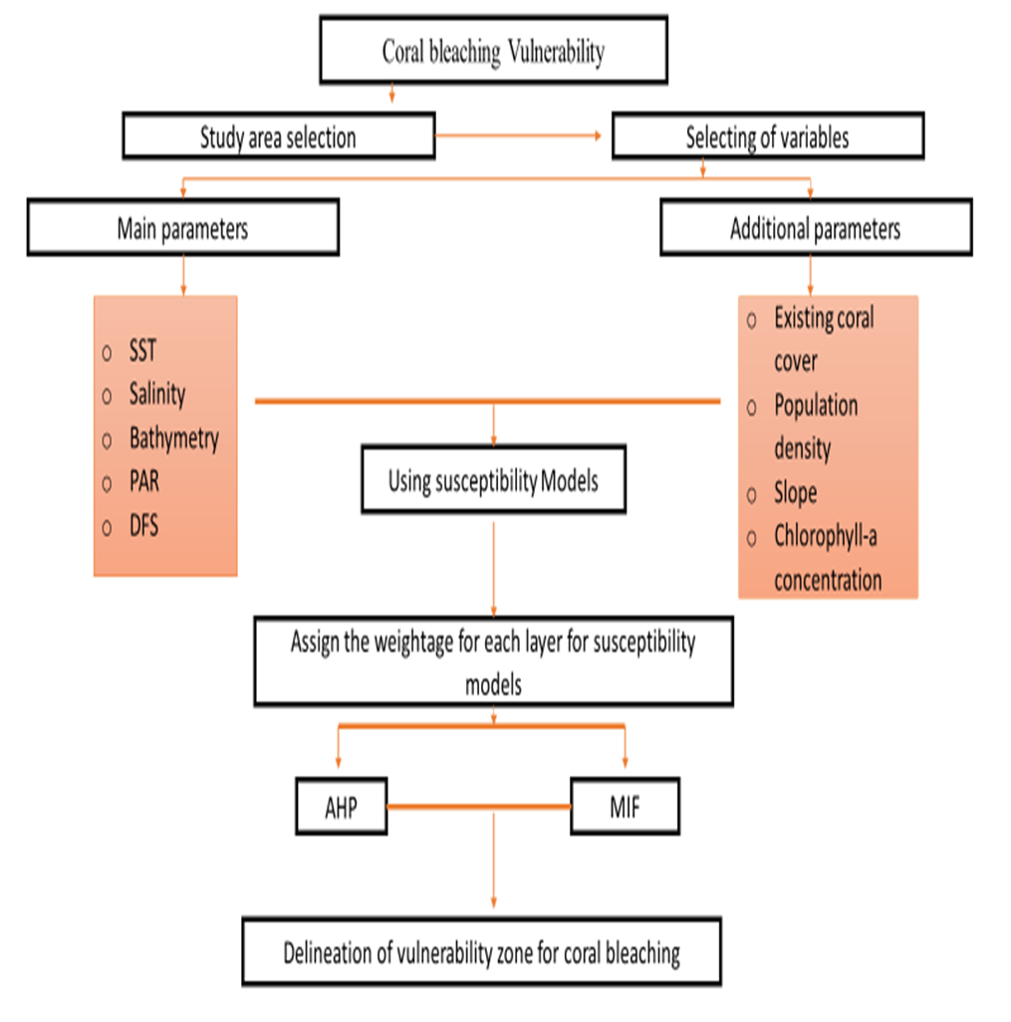

#### 4.3. Data base generation

#### 4.3.1. Sea Surface Temperature Map

The main cause of coral bleaching today is rising temperatures due to global warming. Bleached corals do not die immediately, but if the temperature is very hot, or too warm for a sustained period of time, they will die from hunger or disease. The sea surface temperature is higher in the southern region as it is near to the equator. In 2010 the sea surface temperature in Andaman is very high at 37℃ (between 2005-2015) and the lowest was in 2012 which was 27℃. The average sea surface temperature (between 2005-2015) was 34℃. The sea surface temperature was fluctuating regularly year by year which can be seen in the year wise sea surface temperature map shown below. The maximum SST for 2005 is 33℃ and the minimum SST for 2005 is 27.5℃. The maximum SST for 2006 is 32℃ and minimum SST 28.3℃ which is shows in the fig.6. The Maximum and Minimum SST for 2007 is33.5℃ and 28.3℃, 2008 Maximum and Minimum SST for Andaman region is 32 ℃ and 28℃ , in 2009 Maximum and Minimum SST is 34℃ and 28℃, 2010 Maximum and Minimum SST is37.4℃ and 28.1℃ which is show in fig 7. The Maximum and Minimum SST for 2011 is 34.1℃ and 28℃, In 2012 The Maximum and Minimum SST 33℃ and 27.9℃, In 2013 the Maximum and Minimum SST is 34.61℃ and 27.91 ℃, In 2014 Maximum and Minimum SST is 33.1℃ and 27℃ which show in the fig.8 and the 2015 Maximum and Minimum SST is 34.6℃ and 28℃ which is shows in the fig. 9.

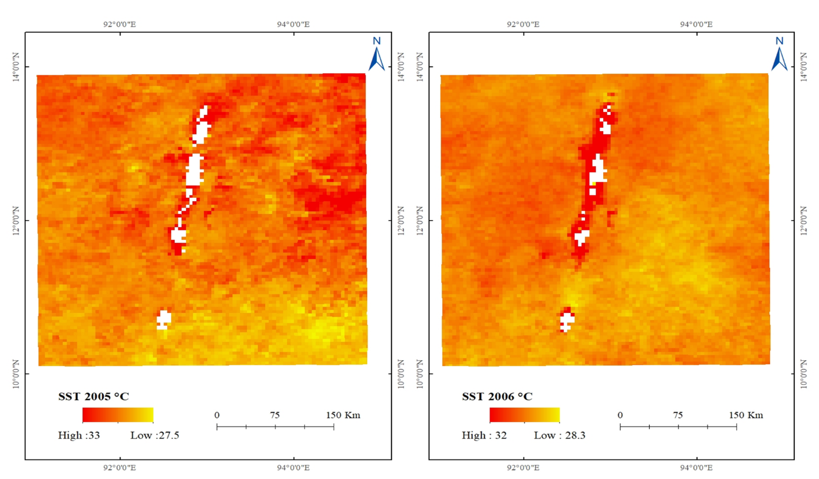

Figure 6 Spatial variation SST for 2005 and 2006

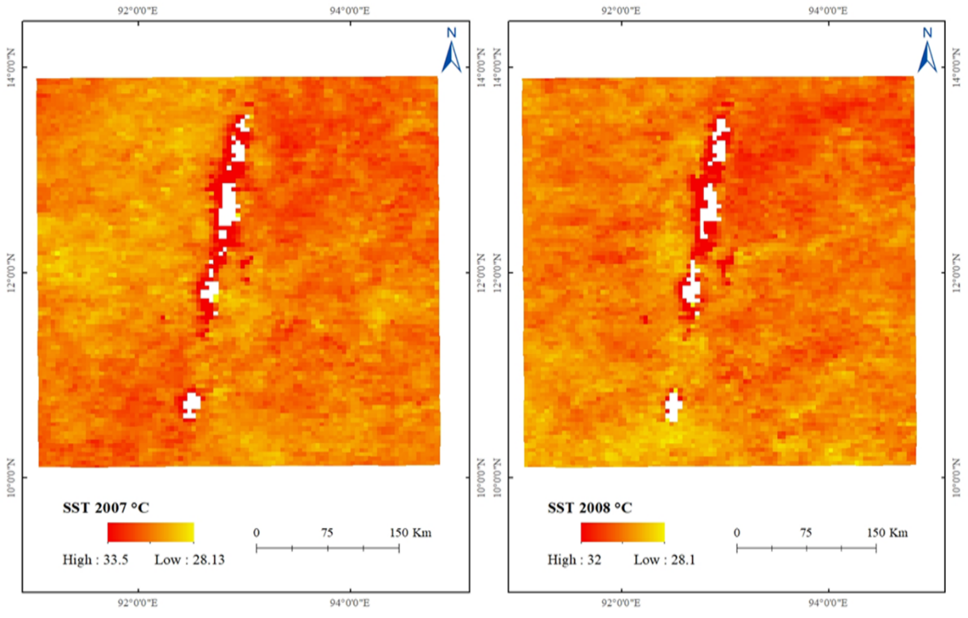

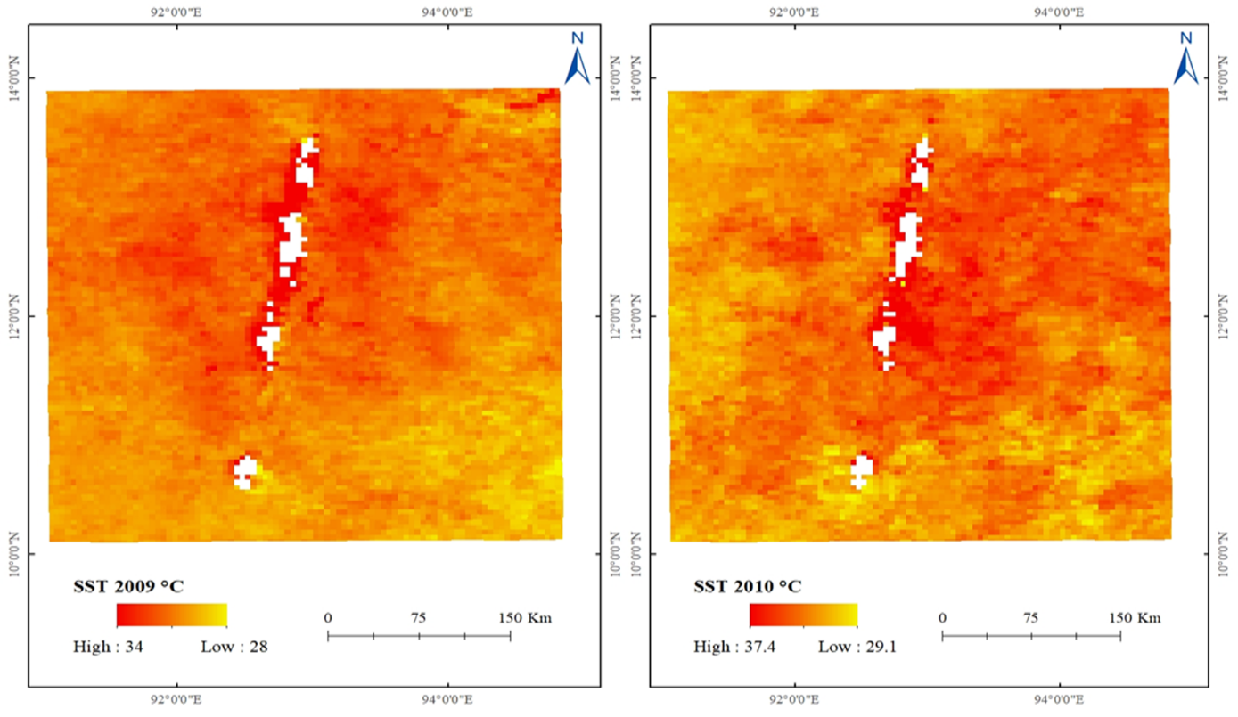

Figure 7 spatial variation of SST for 2007, 2008,2009&2010

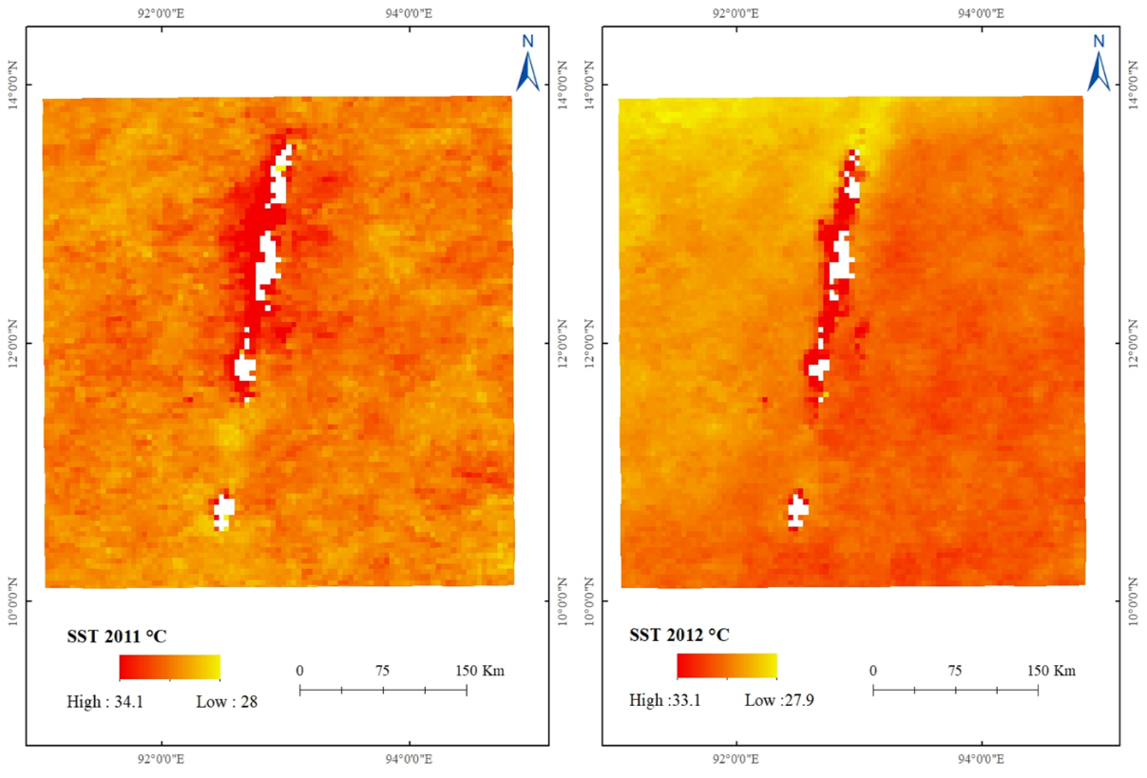

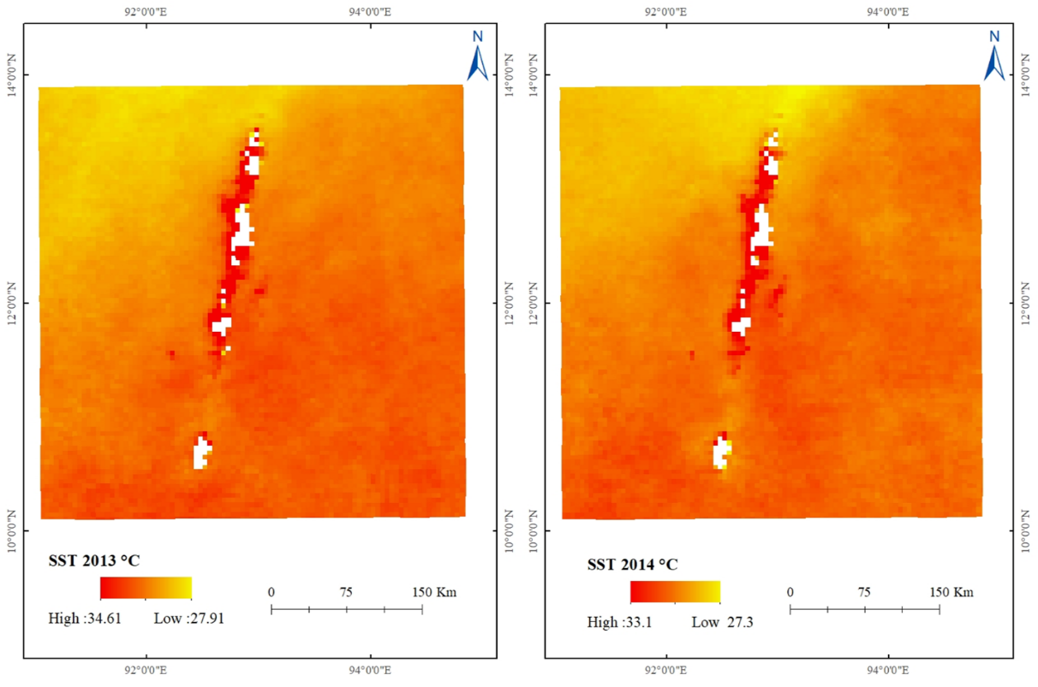

Figure 8 spatial varitation of SST for 2011,2012,2013 & 2014

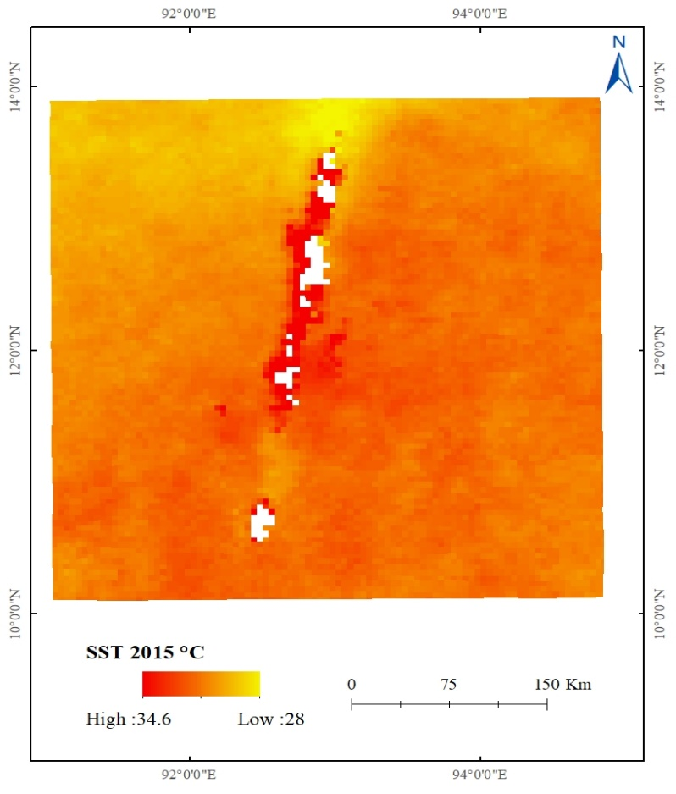

Figure 9 spatial variation of SST for 2015

Long Term Temporal variation on Sea Surface Temperature

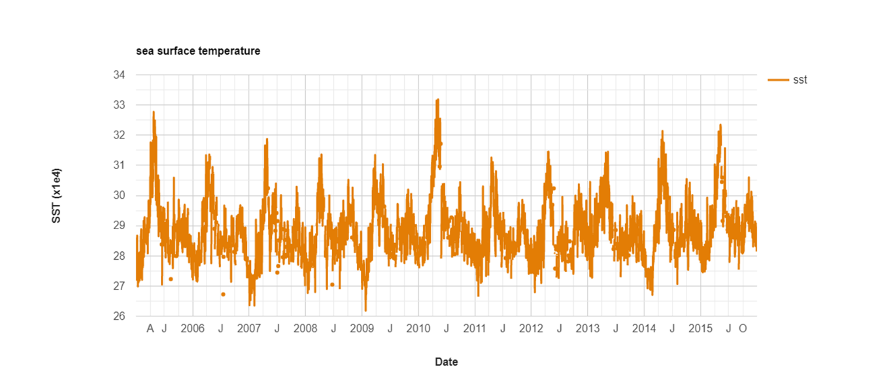

Figure 10 long term temporal variation of SST

#### 4.3.2. Salinity Map

Reduced salinity in the water has been found to be a major leading factor of Coral Bleaching. This process is believed to happen due to the fact that corals are "osmoconformers." This means that corals will gain or lose water to try and keep an isotonic environment around them. This means that when water with low salinity comes near the coral, this organism will intake water to reduce its salt concentration. This process will end up reducing the amount of “symbiotic dinoflagellates from host tissues” causing the coral bleaching. The salinity is comparatively higher in the southern region of Andaman Island than the northern region. The discharge of freshwater from the rivers in the northern part of India e.g. Ganga, Brahmaputra, etc is high in the northern region so the salinity level is lesser in the northern region of Andaman Island. The water with higher salt concentration will move to warmer areas, while low salt concentration will lay near cold water. This means that corals that are located near tropical areas will exhibit higher salinity, while those coral that lie closer to colder water has lower salinity.

The salinity map for 2005 which shows in fig.11 the Maximum and Minimum salinity was 14896.2 PSU and 13322.9 PSU and 2006 salinity was 14724 and 13332 PSU. The maximum and minimum salinity for 2007 is 14888 PSU and 12895 PSU, 2008 the Maximum and Minimum salinity is 14657 PSU and 13334 PSU which is shown in fig. 12. 2010 the Maximum and Minimum salinity is 14822 PSU and 13230 PSU which is shown in fig.13. 2011 the Maximum and Minimum salinity is 14653 PSU and 13023 PSU, in 2012 Maximum and minimum salinity is 14764 PSU and 13195 PSU which is shown in fig.14. 2013 The maximum and minimum salinity is 14374 PSU and 13553 PSU. 2014 maximum and minimum salinity is 14227 PSU and 13536 PSU. Which is shown in fig. 15. In 2015 maximum and minimum salinity is 14114 and 13362 PSU. Which is shown in fig.16.

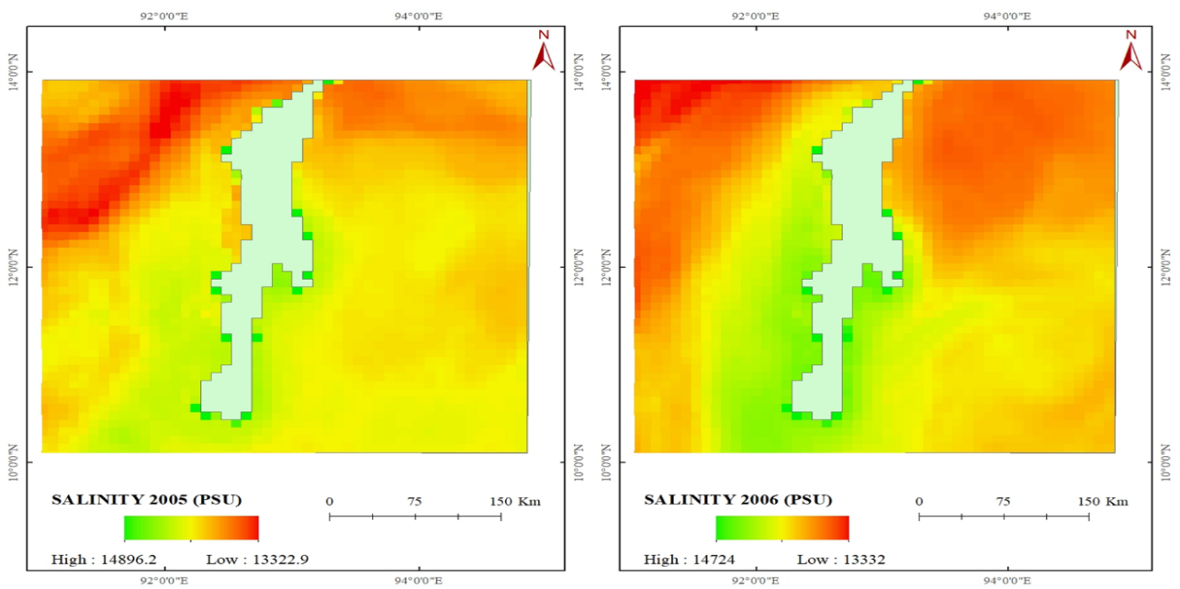

Figure 11 spatial variation of salinity 2005 & 2006

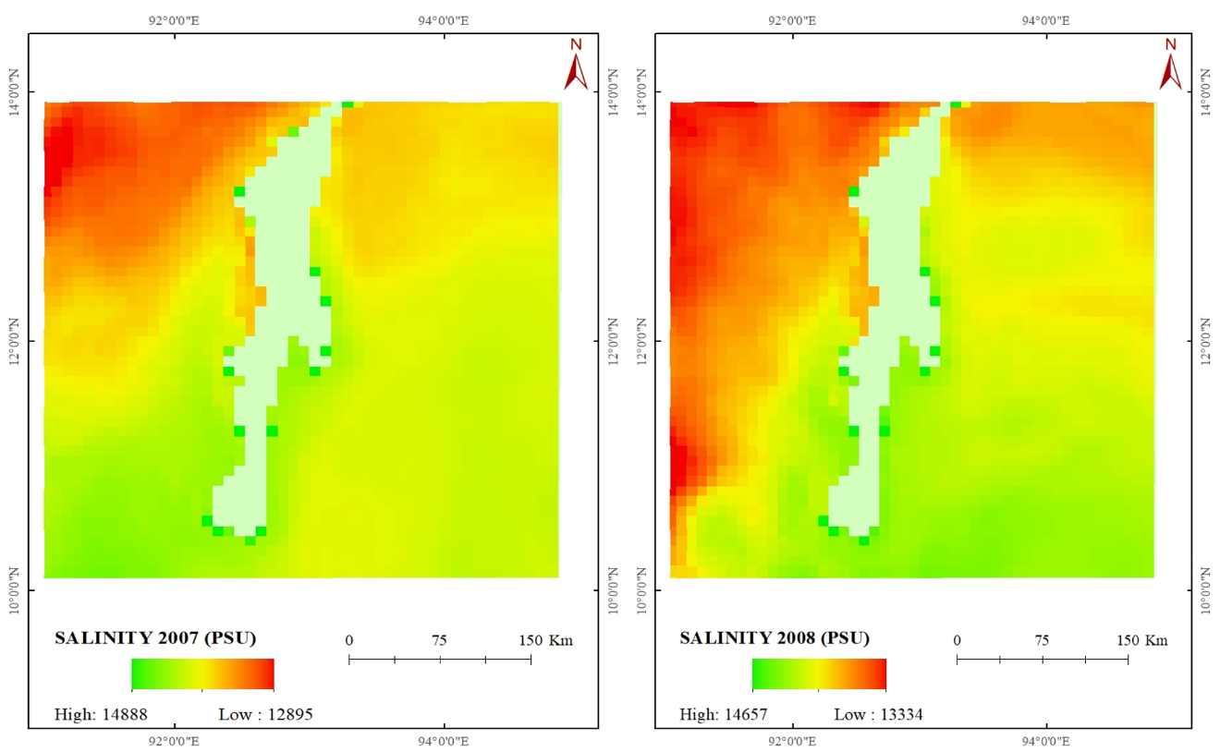

Figure 12 spatial variation for salinity 2007 & 2008

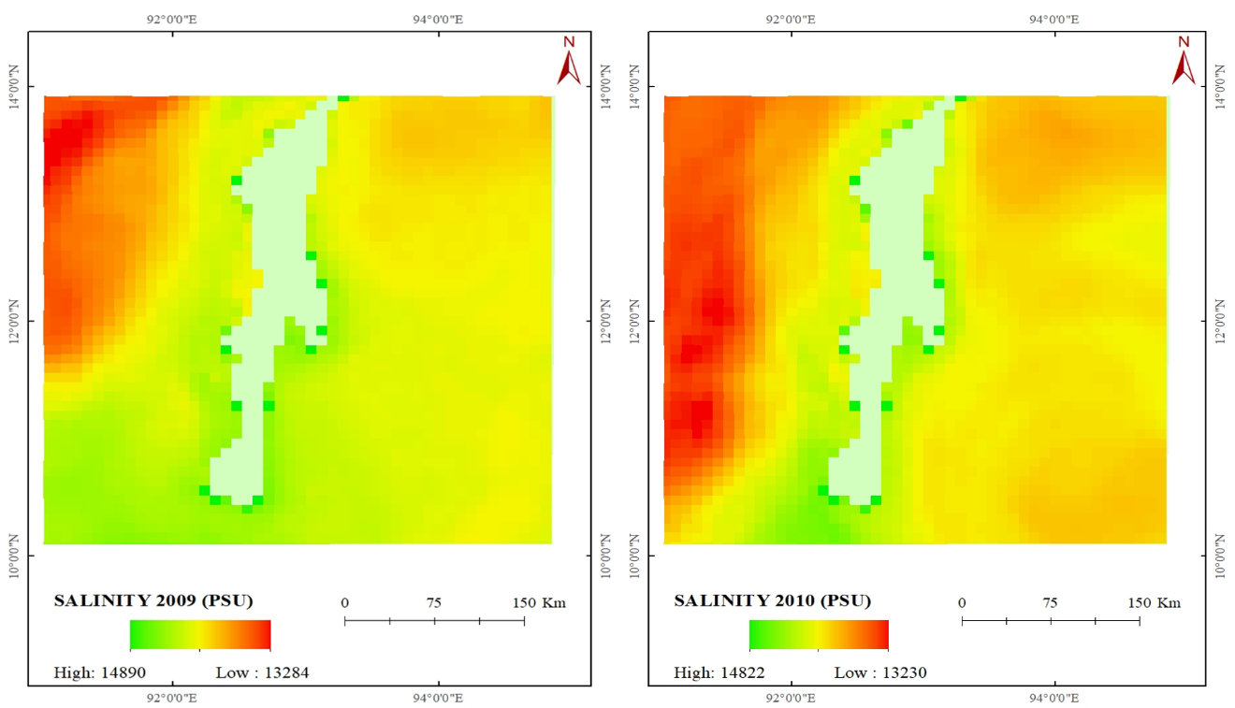

Figure 13 spatial variation for salinity 2009 & 2010

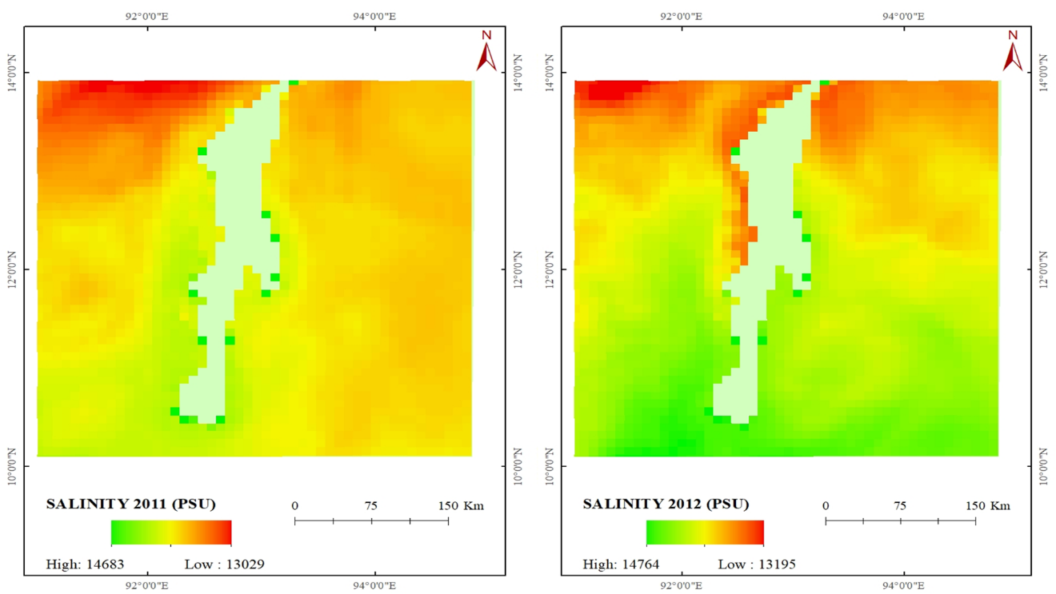 Figure 14 spatial variation for salinity 2011 & 2012

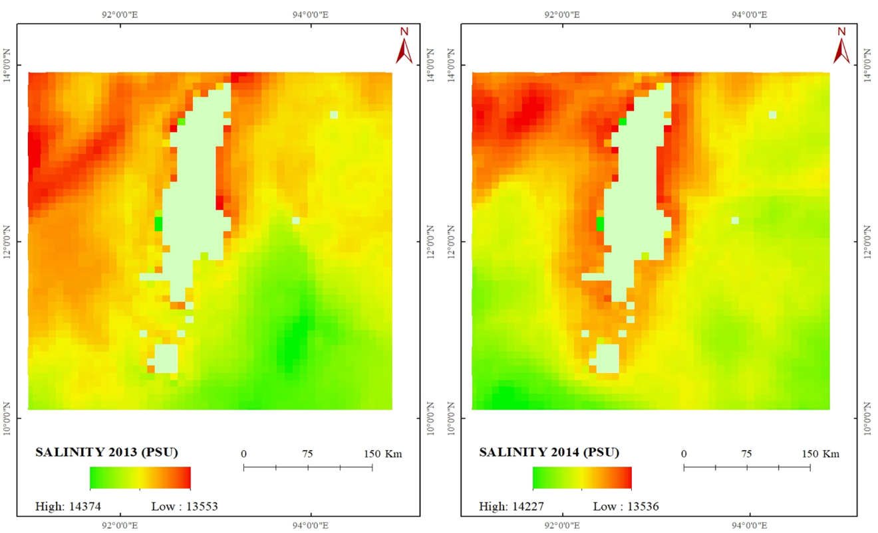

Figure 15 spatial variation for salinity 2013 & 2014

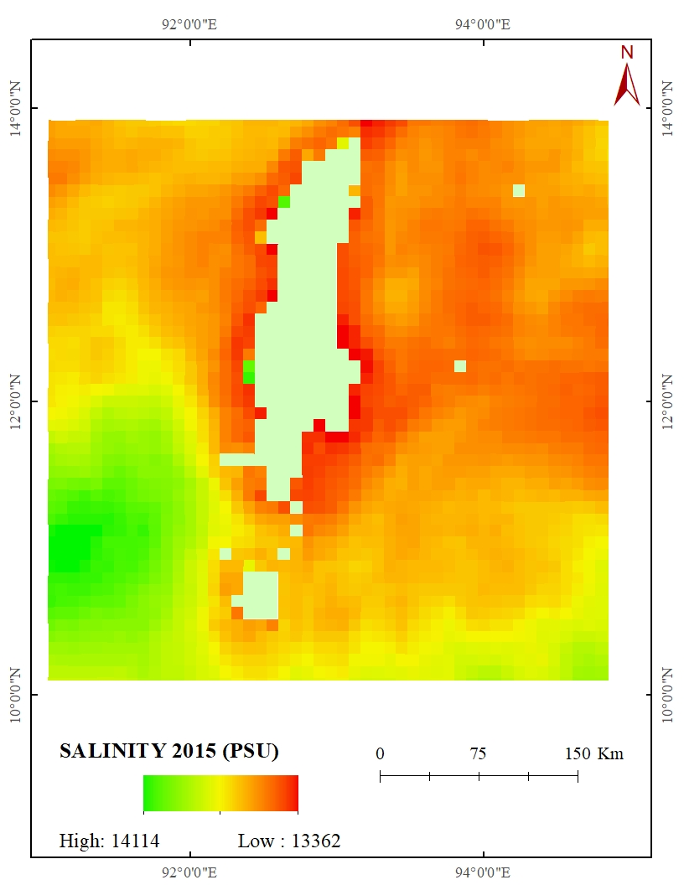

Figure 16 spatial variation for salinity 2015

The long term spatial variation on Sea Salinity:

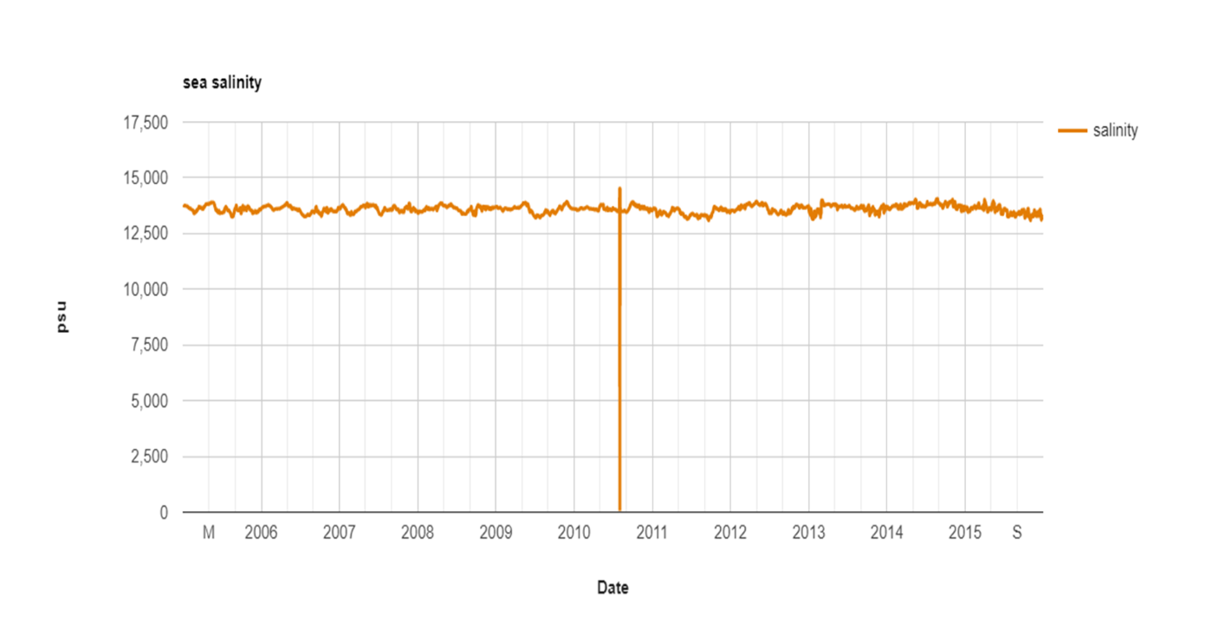

Figure 17 Long term spatial variation for salinity

#### 4.3.3. Chlorophyll-a Concentration

Chlorophyll-A is a green pigment found in plants. It absorbs sunlight and converts it to sugar during photosynthesis. Chlorophyll a concentrations are an indicator of phytoplankton abundance and biomass in coastal and estuarine waters. It is natural for chlorophyll *a* levels to fluctuate over time. Chlorophyll *a* concentrations are often higher after rainfall, particularly if the rain has flushed [nutrients](https://ozcoasts.org.au/indicators/biophysical-indicators/water_column_nutrients/) into the water. Higher chlorophyll *a* levels are also common during the summer months when [water temperatures](https://ozcoasts.org.au/indicators/biophysical-indicators/temperature/) and light levels. If salinity is higher then the chlorophyll concentration will be lower. In the map we can identify the chlorophylls in blue color which is found along the shore. It is so because the corals are found only near the shore, so the chlorophyll concentration found along the shore of Andaman Island. The chlorophyll- a concentration variation over 2005 to 2015 is shown in below. In 2005 The maximum and minimum concentration is 1.34 mg/m-3 and 0.15 mg/m-3. In 2006 maximum and minimum concentration is 1 mg/m-3 and 0.13 mg/m-3, 2007 the maximum and minimum concentration is 3 mg/m-3 and 0.14 mg/m-3, in 2008 maximum and minimum concentration is 1.1 mg/m-3 and 0.13 mg/m-3. Which is shown in fig.18. In 2011 the maximum and minimum concentration of chlorophyll-a is 1.2 mg/m-3 and 0.1 mg/m-3. And 2012 the maximum and minimum concentration is 1 mg/m-3 and 0.1 mg/m-3. Which is shows in fig 20. In 2013 the maximum concentration is 1.23 mg/m-3 and 0.12 mg/m-3. In 2014 maximum and minimum concentration is 1.4 mg/m-3 and 0.12 mg/m-3 which is shows in the fig 21. The maximum and minimum concentration of chloral-a is 2.5 mg/m-3 and 0.11 mg/m-3, which is shown in the fig 22.

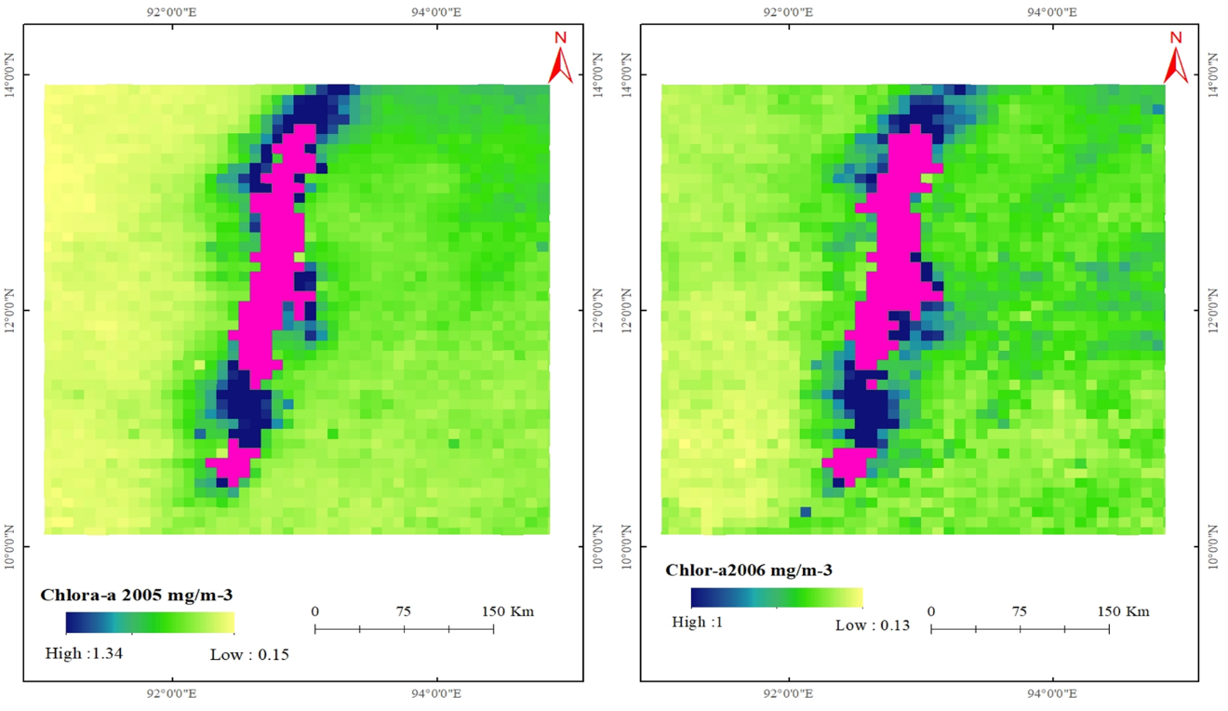

Figure 18 spatial variation for Chlorophyll-a 2005 & 2006

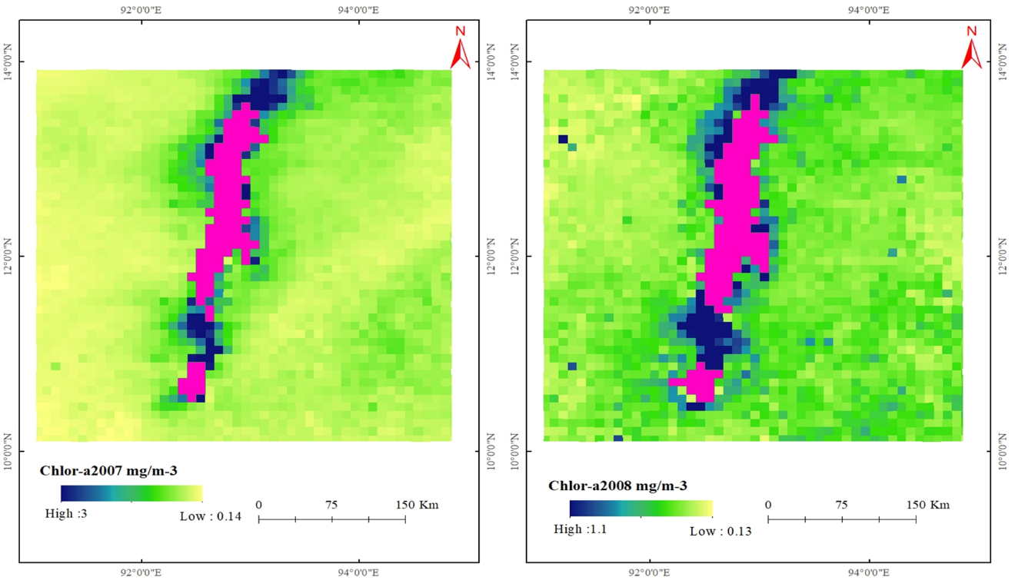

Figure 19 spatial variation for chlorophyll-a 2007& 2008

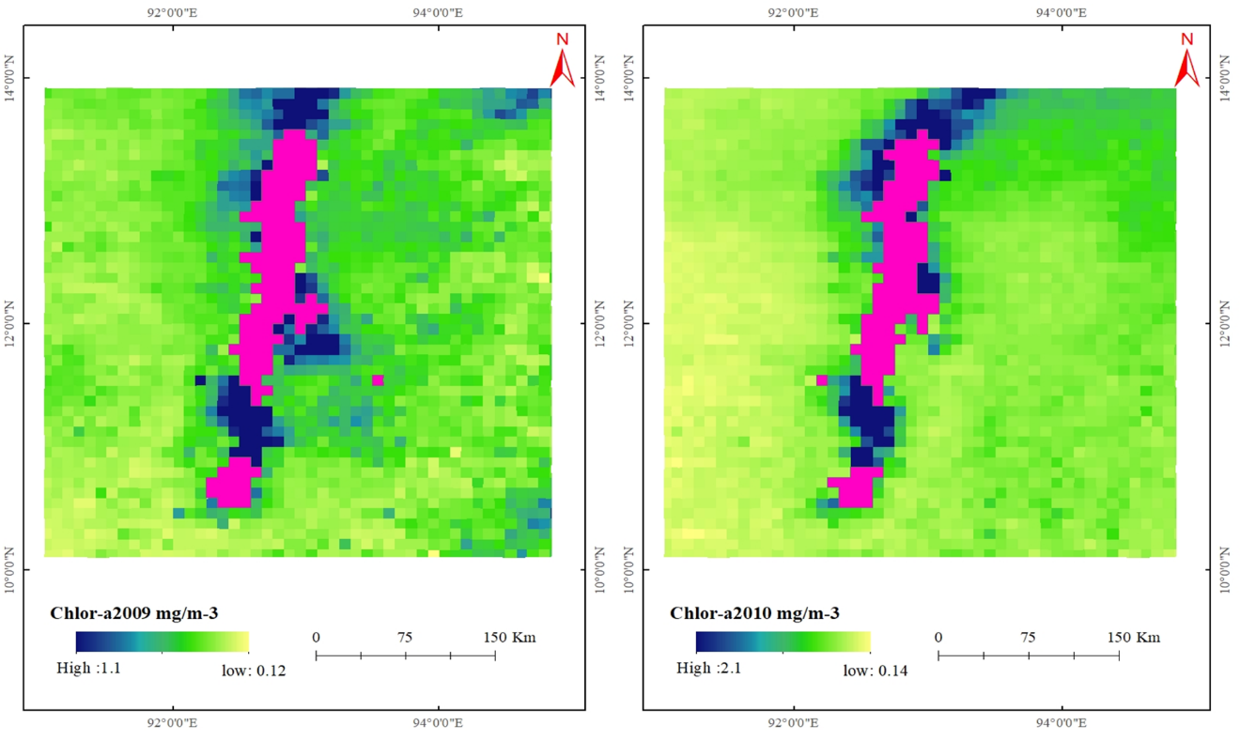

Figure 20 spatial variation for chlorophyll-a 2009 & 2010

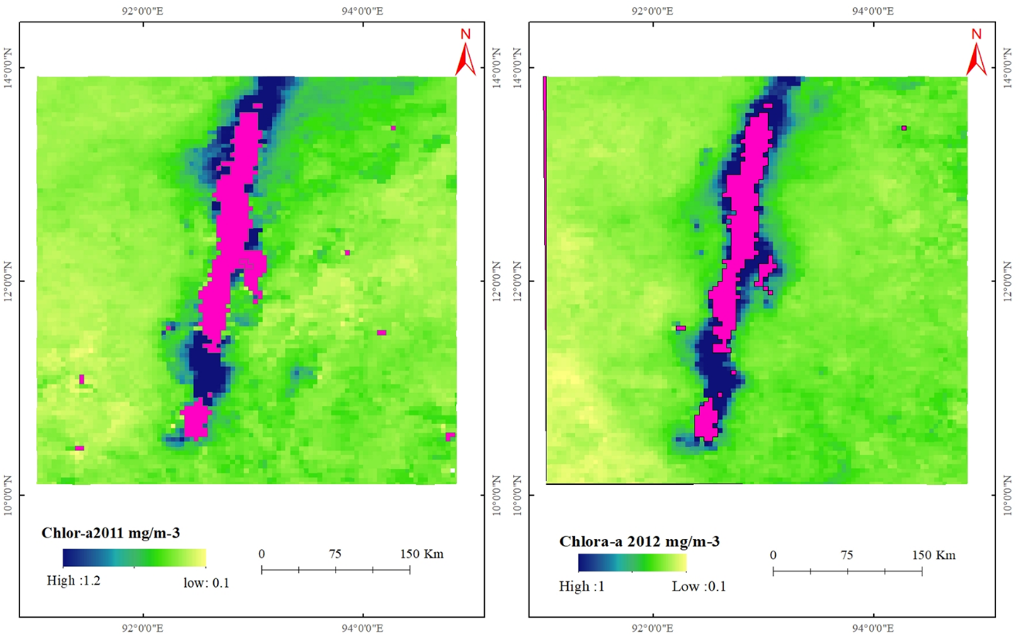

Figure 21 spatial variation for chlorophyll-a 2011 & 2012

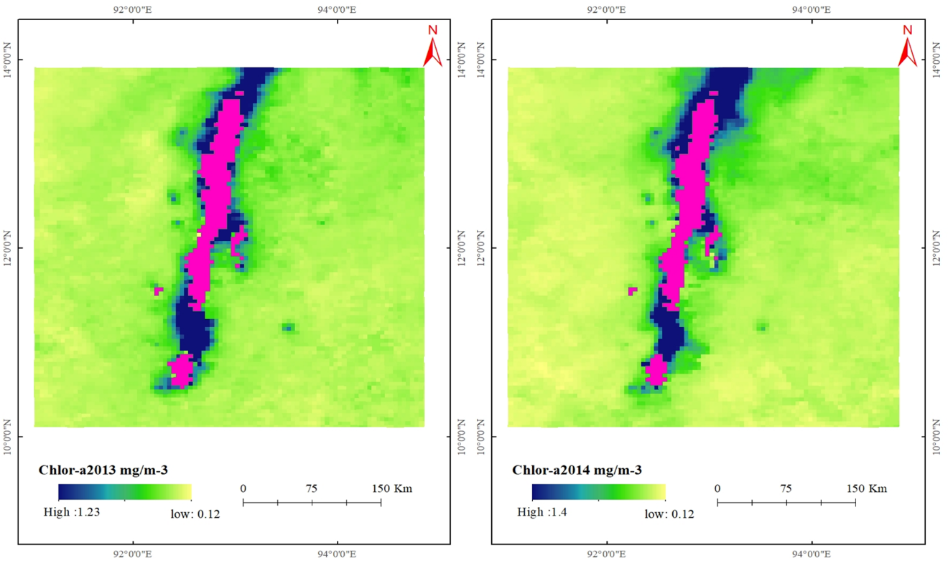

Figure 22 spatial variation for chlorophyll-a 2013 & 2014

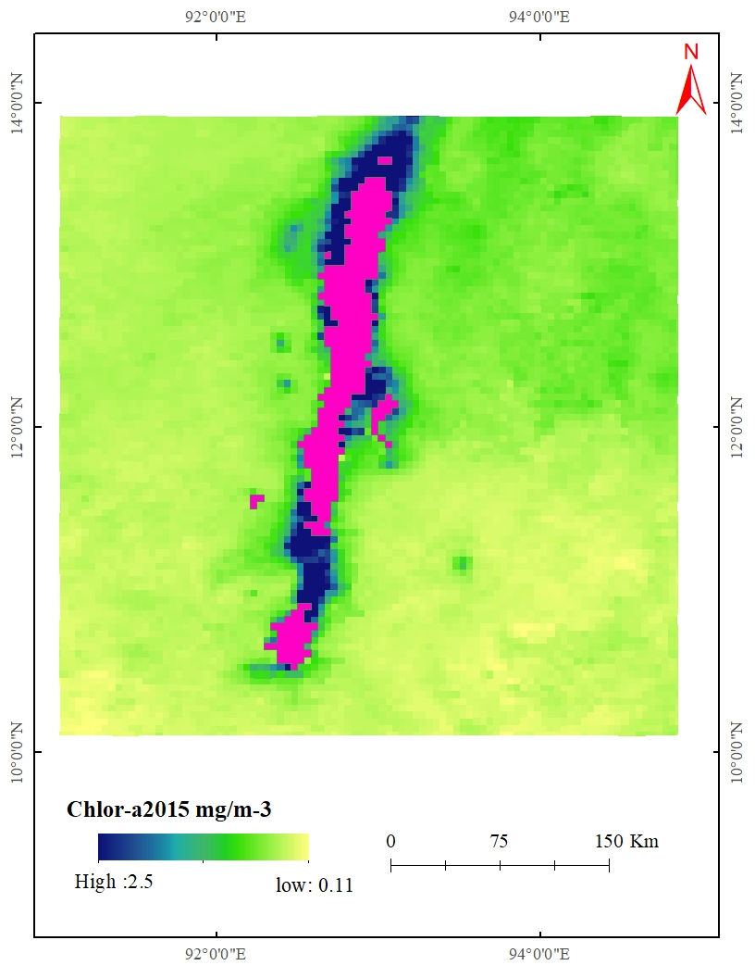

Figure 23 spatial variation for chlorophyll-a 2015

Long term temporal variation on Chlorophyll-A Concentration:

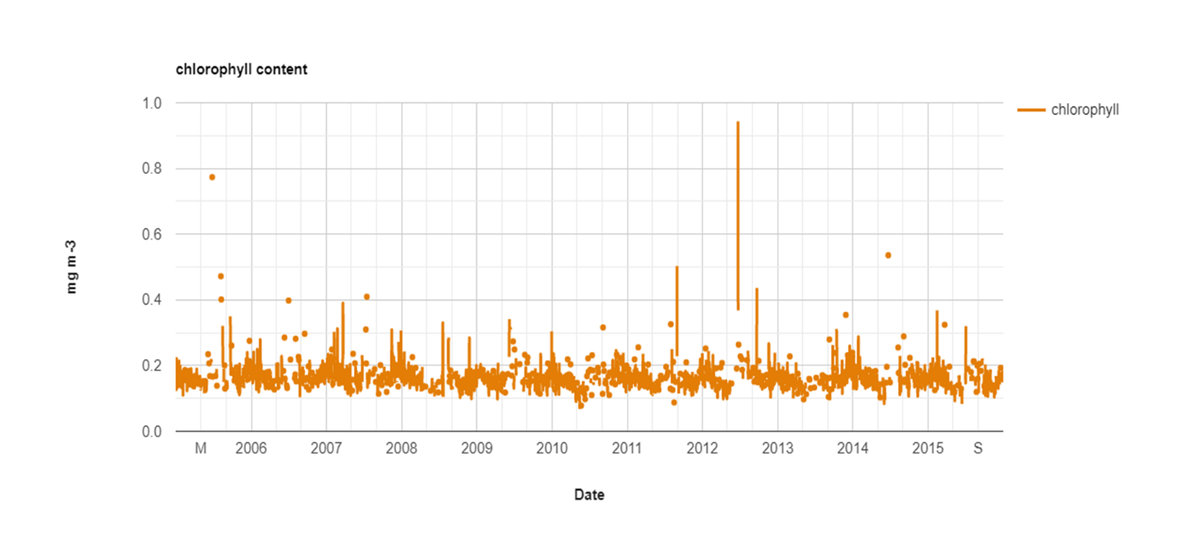

Figure 24 long term spatial variation for chlorophyll-a

#### 4.3.4. Bathymetry

For studying coral reefs, a bathymetric map is important as a base map. It influences many factors on reef ecosystems for both coral and reef, influencing the structure of coral reef communities mainly due to light attenuation. Changes in water temperature and resource availability, the shallow level bathymetry is suitable for the growth of corals. In shallow level bathymetry depth of the sea bed is very low so, the sun light can easily penetrate through water which makes photosynthesis process easier. The water temperature usually falls with water depth, because of less sunlight penetration to greater depth. Most aquatic organisms have a limited range of tolerance to temperature changes. The bathymetry in Andaman Island is between 517m to -4420m. The bathymetry map is shown in fig. 24.

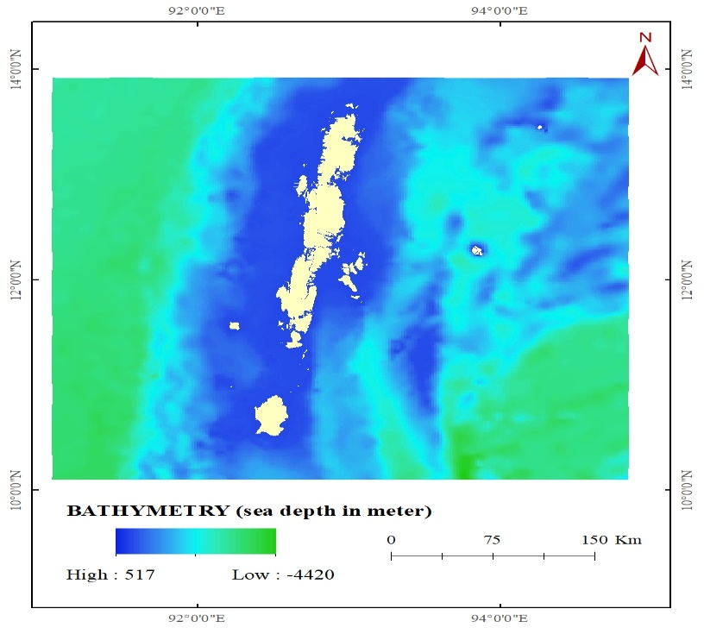

Figure 25 spatial variation for bathymetry

#### 4.3.5. Photosynthetically Available Radiation

Photosynthetically Available Radiation (PAR) is the amount of light available for photosynthesis, which is light in the 400 to 700 nano meter wavelength range. PAR changes seasonally and varies depending on the latitude and time of day. Photosynthetically Active Radiation is needed for photosynthesis and plant growth. Higher PAR promotes plant growth, and monitoring PAR is important to ensure plants are receiving adequate light for this process. Light is a key factor for coral survival and physiology of corals that contain symbiotic zooxanthellae. When respiratory need of zooxanthellae is met with requirements, the excess photosynthetic products are transferred to coral host for growth and other activities.

However, excessive light intensity can cause a reduction of photosystem II quantum efficiency and lead to bleaching. In addition, the high solar radiation including photosynthetically available radiation (PAR). If the photosynthetically available radiation is higher the coral cover in that particular region will also be higher. In Andaman region the photosynthetically available radiation ranges between 861-223nm. The photosynthetically available radiation is comparatively higher in the western region, it is due to the coral density is higher in western region of the Andaman Island. In 2005 the PAR maximum and minimum is 57.9 and 161, 2010 the maximum and minimum PAR is 58 and 41 which is shown in fig 25. In 2015 the maximum and minimum PAR IS 57 and 32. Which is shown in fig.26.

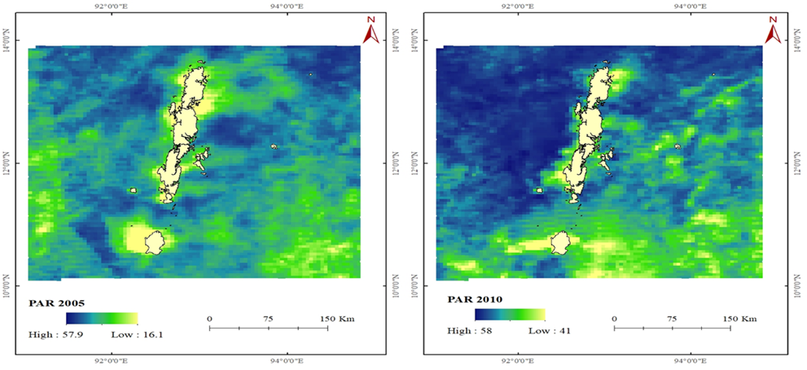

Figure 26 spatial variation for PAR 2005 & 2010

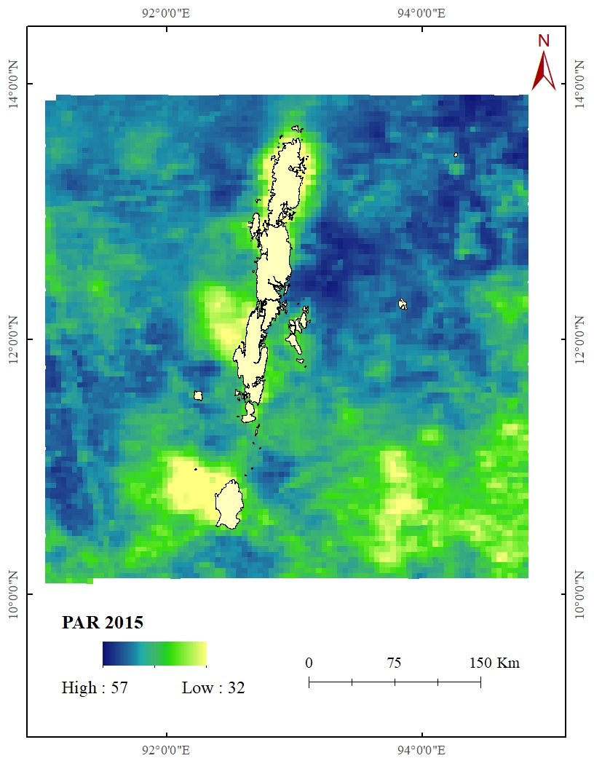

Figure 27 spatial variation for PAR 2015

#### 4.3.6. Distance From Shore

Coral cover declines with distance from the shore (596 m). Identified coral taxonomy exhibited clear depth stratification, corresponding closely to light attenuation and sea floor topography, with reef development restricted to submarine antecedent bedform. Corals are mostly found near the shore line as they prefer shallow depth and saline water for their healthy growth. The human intervention will also be higher in places were the distance from corals is lesser and it may affect the growth of corals. The tourist activities are comparatively less were the distance from shore is higher, so that the corals around those regions are less affected. The distance from the shore map is shown in fig. 27.

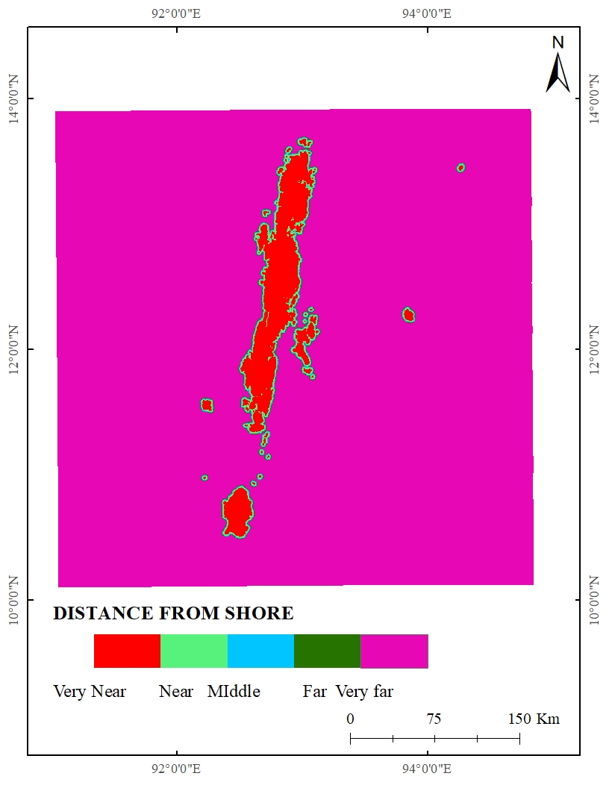

Figure 28 spatial variation for distance from shore

#### 4.3.7. Slope

Slope power change refers to the slope change found in sea bed. The slope of the sea bed is slope power change map. We classified into five classes 0.1.7 is very low slope and 1.8 to4.8 is low slope, 4.9 to9 is moderate slope 9.1 to 15 is high slope and 16 to 54 is very high slope. Very low slope is suitable for coral grow, corals are mostly grow in shallow level depth. Shallow level sea bed is more suitable for grow when compared to deep level sea slope. The slope map shown in fig.28 very low is slope is 0-1.7 degree, low slope is 1.8-4.8, medium slope is 4.9- 9 the high slope is 9.1-15 the very high slope is 16-54. Which is shown in fig. 28

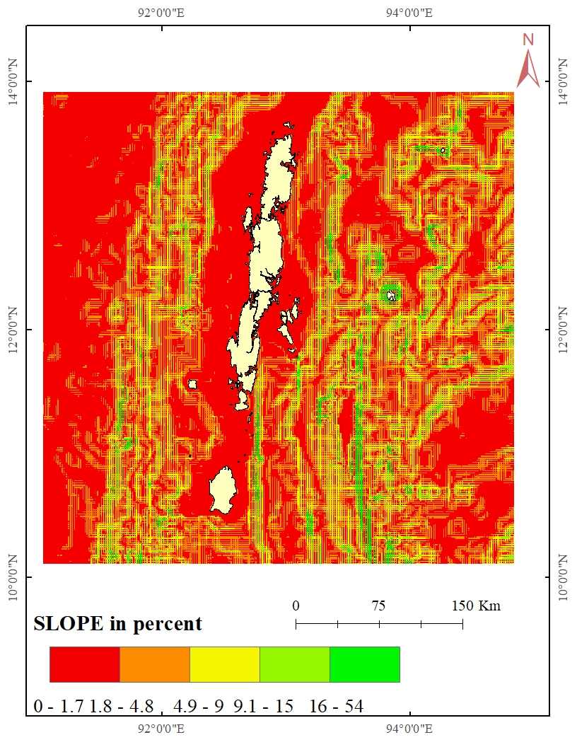

Figure 29 spatial variation for Slope

#### 4.3.8. Population Density

Andaman Islands is one of state in India with population of 380581. There are 3 districts, 9 Taluks, 555 villages and 5 towns in Andaman Islands. The population density is used as one of the parameters were the density is higher the corals around that particular regions would affected or polluted due to some human activities. Andaman is also one of the major tourist places in India, so the tourist activities like scuba diving, snorkeling, etc. might also affect the corals. We can also see that the Port Blair region is the highly denser region and also along the beach regions. The population density have been reduced when compared to 2005-2015. One of the major reason for that is the 2004 tsunami which made most people to move out of Andaman Island. The population density map is shown in below, for 2005 the maximum and minimum population density is 333 and 25 per sq.km. In 2010 the maximum and minimum population density is 293 and 23 per sq.km. which is shown in fig. 29. For 2015 maximum and minimum population density is 292 and 23 per person in sq.km which is shown in fig.30.

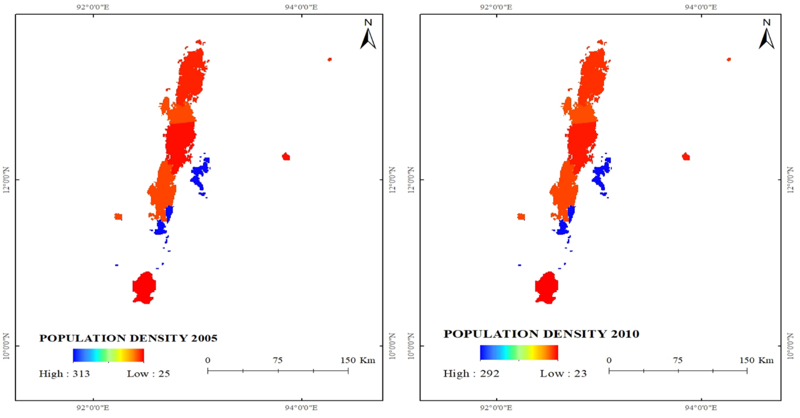

Figure 30 Population Density for 2005 & 2010

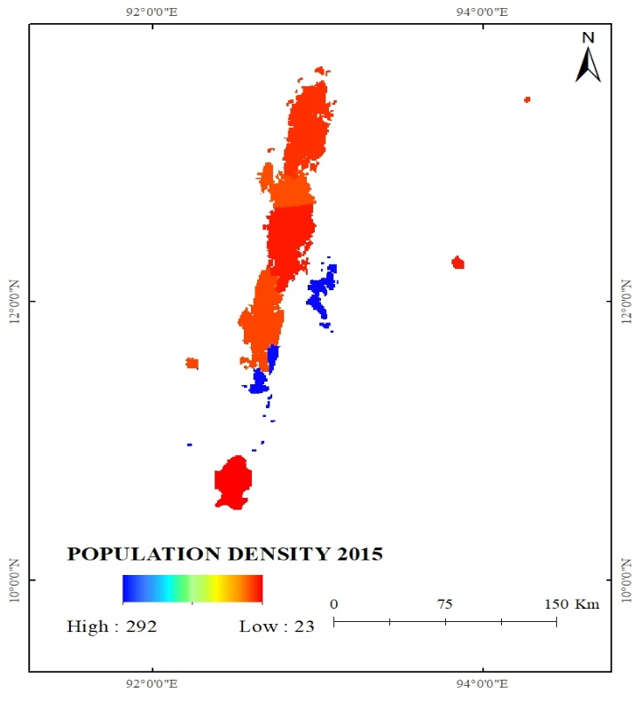

Figure 31 Population Density for 2015

#### 4.3.9. Existing Coral Cover

The existing coral cover map has been prepared from Allen Coral Atlas (US). It shows the existing corals around the Andaman Island. And we have prepared the boundary using Allen coral Atlas. Existing coral cover is considered because only in the existence of corals further growth of corals can be found.

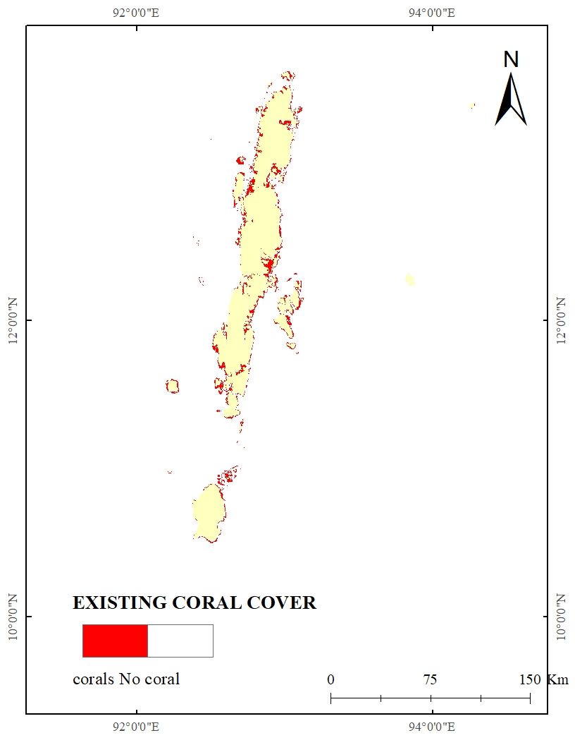

Figure 32 Existing coral map for Andaman Islands

#### 4.3.10. NDWI:

NDWI is normalized difference water index is very strongly related to plant water content. The normalized Difference Water Index is prepared from Landsat5.

NDWI=(NIR-SWIR)/(NIR-SWIR)

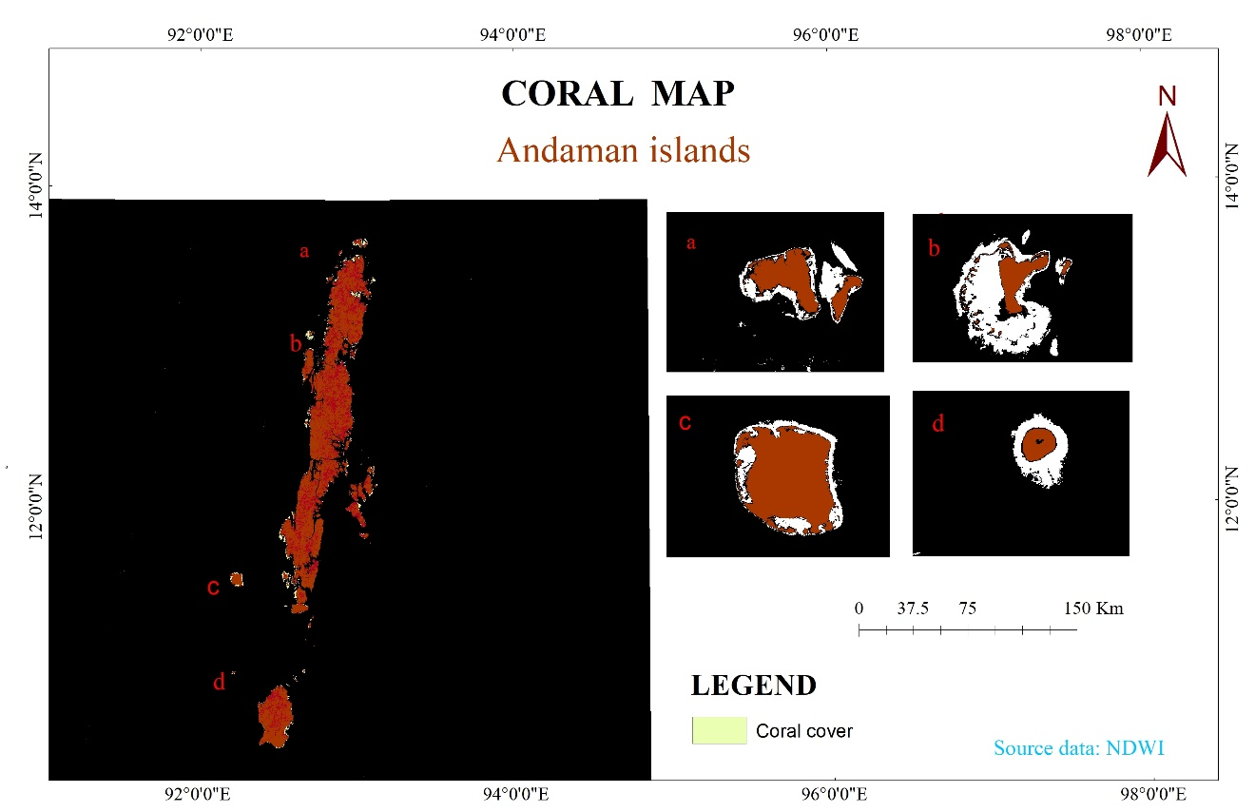

Figure 33 NDWI for Andaman region

The NDWI map clearly show the corals are found only in shallow level depth, the white colour represents the shallow level depth corals.

##### **5. RESULT AND DISCUSSION**

##### **5.1. Integration of Maps and Preparation of Final Vulnerability Map**

In this study we have taken nine variables to fine the coral bleaching vulnerable zone they are Sea surface Temperature, Salinity, Photosynthetically Available Radiation, Distance from shore, Bathymetry, Chlorophyll-a concentration, Existing Coral cover, Population Density and Slope Power Change. These variable were used in the preparation of criteria map. For vulnerability zone analysis it is necessary to give some score to each of the criteria as per their adequacy for vulnerable zone. For this purpose the pair-wise comparison matrix using different criteria are required to create a ratio matrix. These pair wise comparisons are taken as input and relative weights are produced as an output. After the formation of pair wise comparison matrix, computation of the criterion weights has been done. Each variable pixel values entered in coral cover boundary (Allen Coral Atlas US) attribute table for further analysis. After the values entered the attribute table was used to assigned the weightage for each variable were integrated and assigned. To assign the Weightages (1, 2, 3, 4 and 5) and Rank for each parameter, according to the influencing of vulnerable zone for coral bleaching, the high weightage for Sea Surface Temperature and low weightage for Existing coral cover have been assigned for both AHP and MIF model and reclassified into five classes as Very High, High, Medium, Low and Very Low and enter the reclassified pixel value of each parameter into coral cover boundary (ACA US) attribute table.

5.2. AHP Weightage

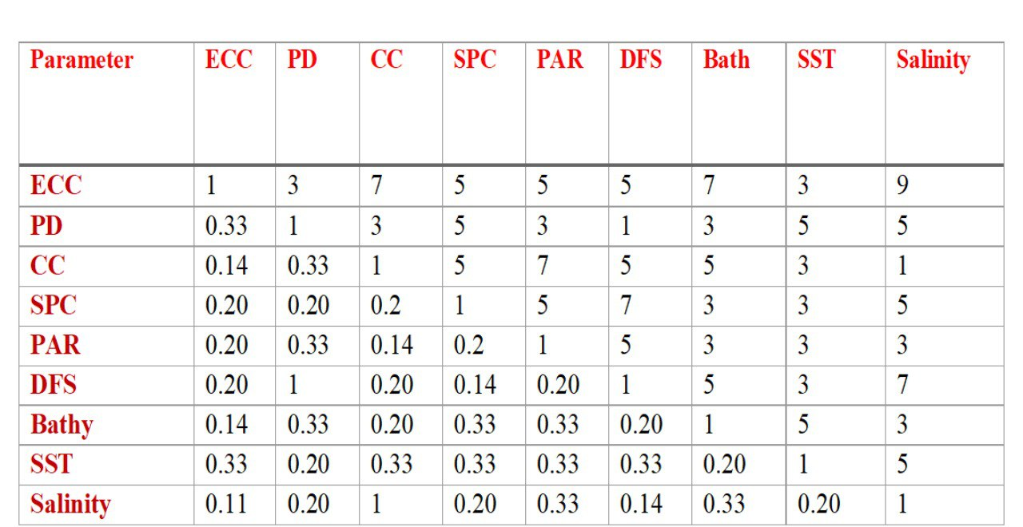

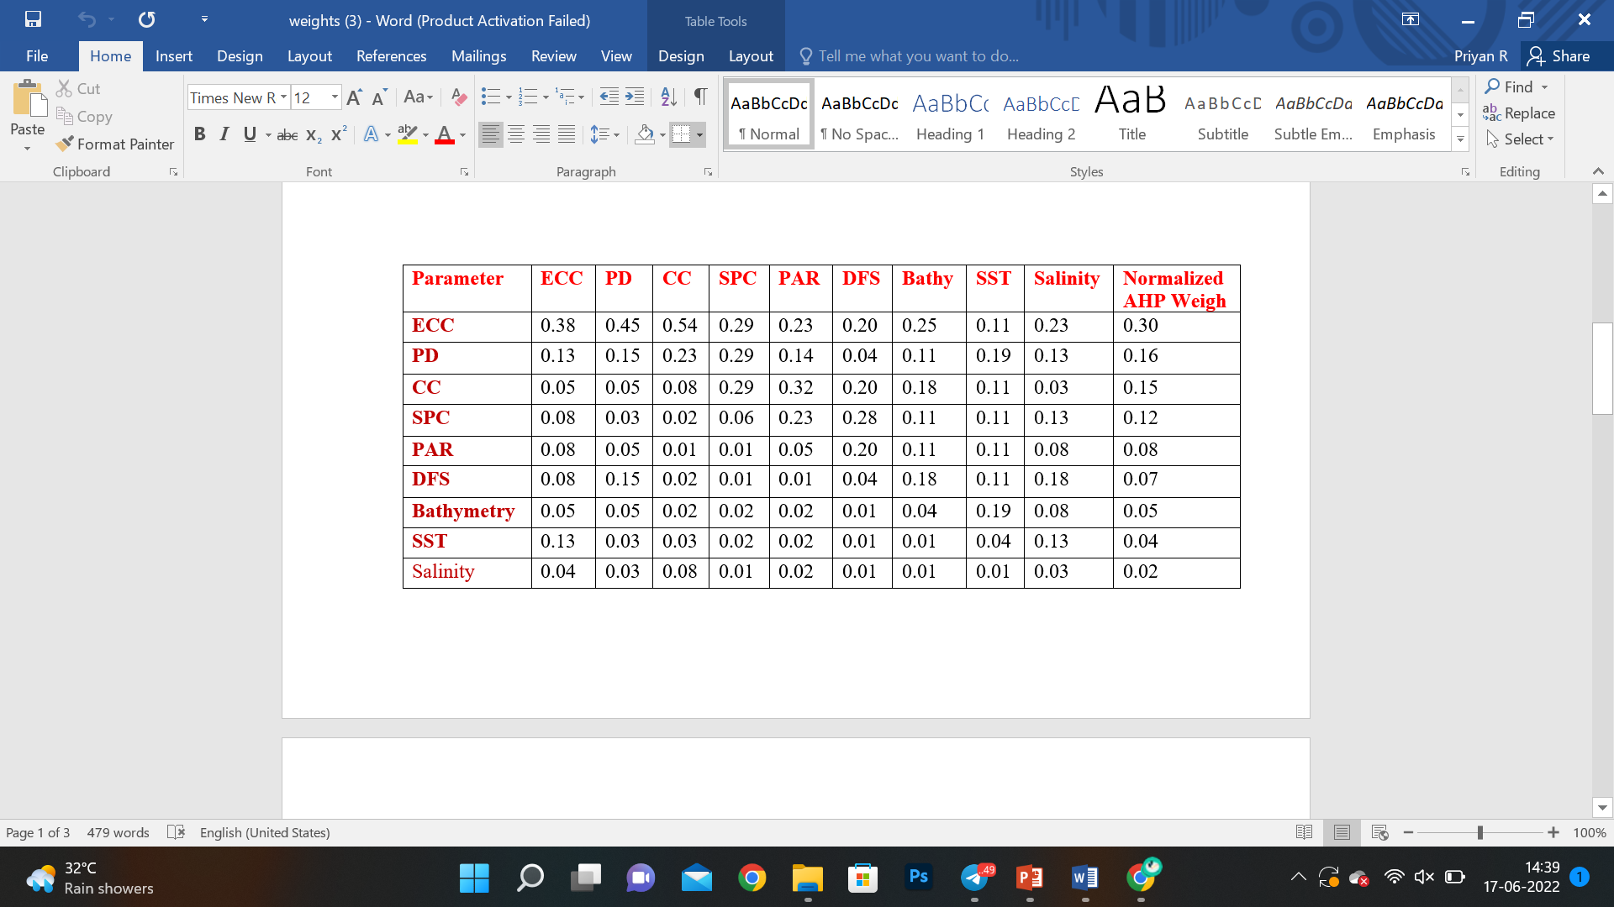

Table 1 AHP weightage

##### **5.3. MIF Weightage**

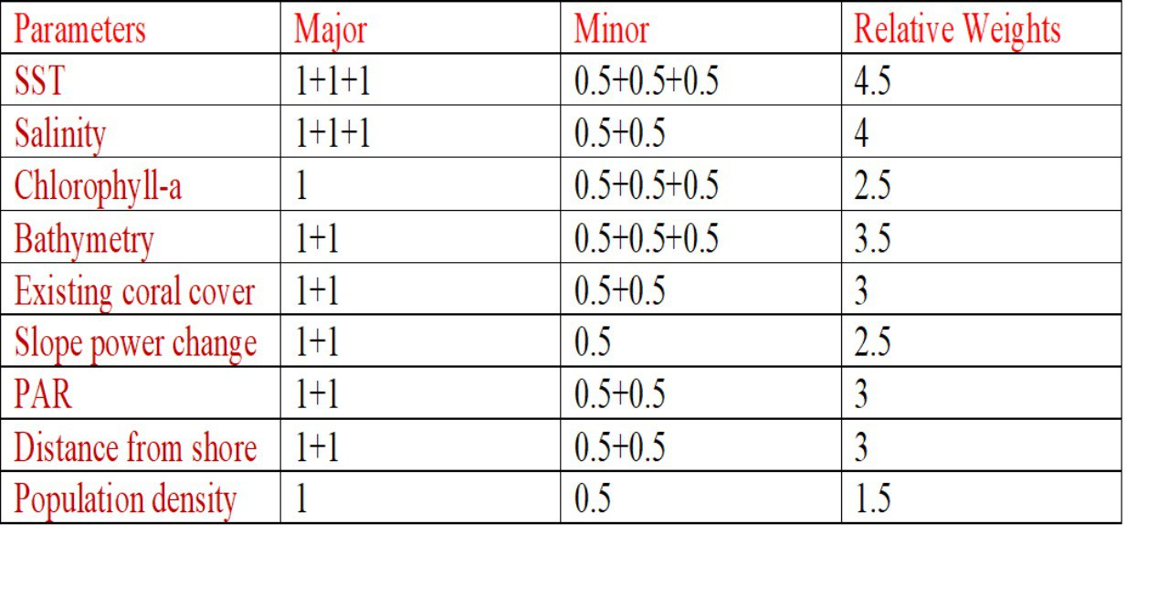

Table 2 MIF weightage

##### **5.4. Overall Weight and Rank for Both Susceptibility Models**

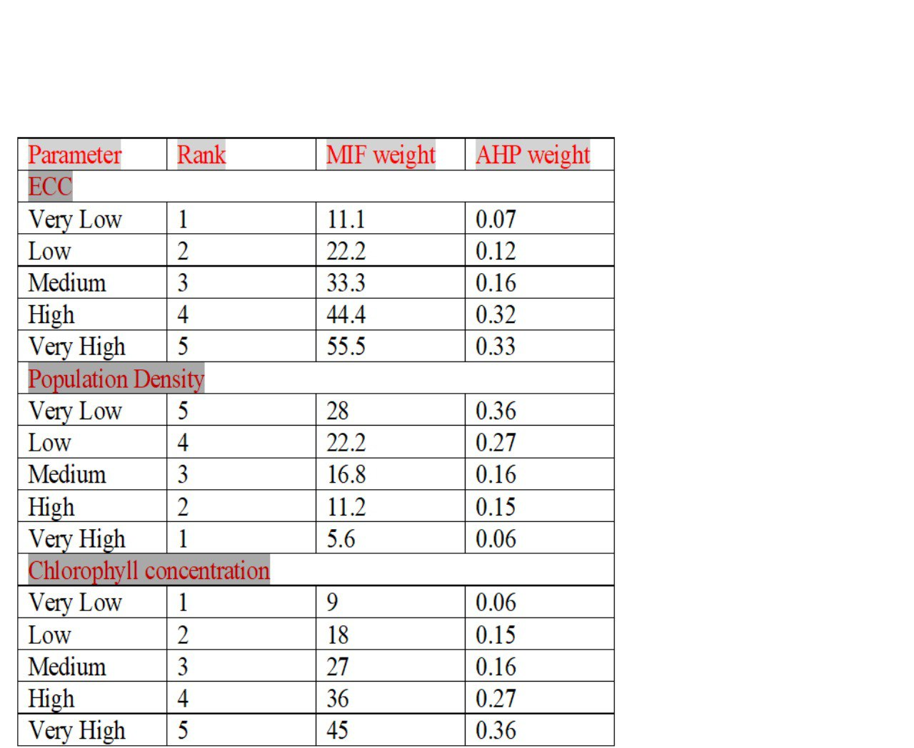

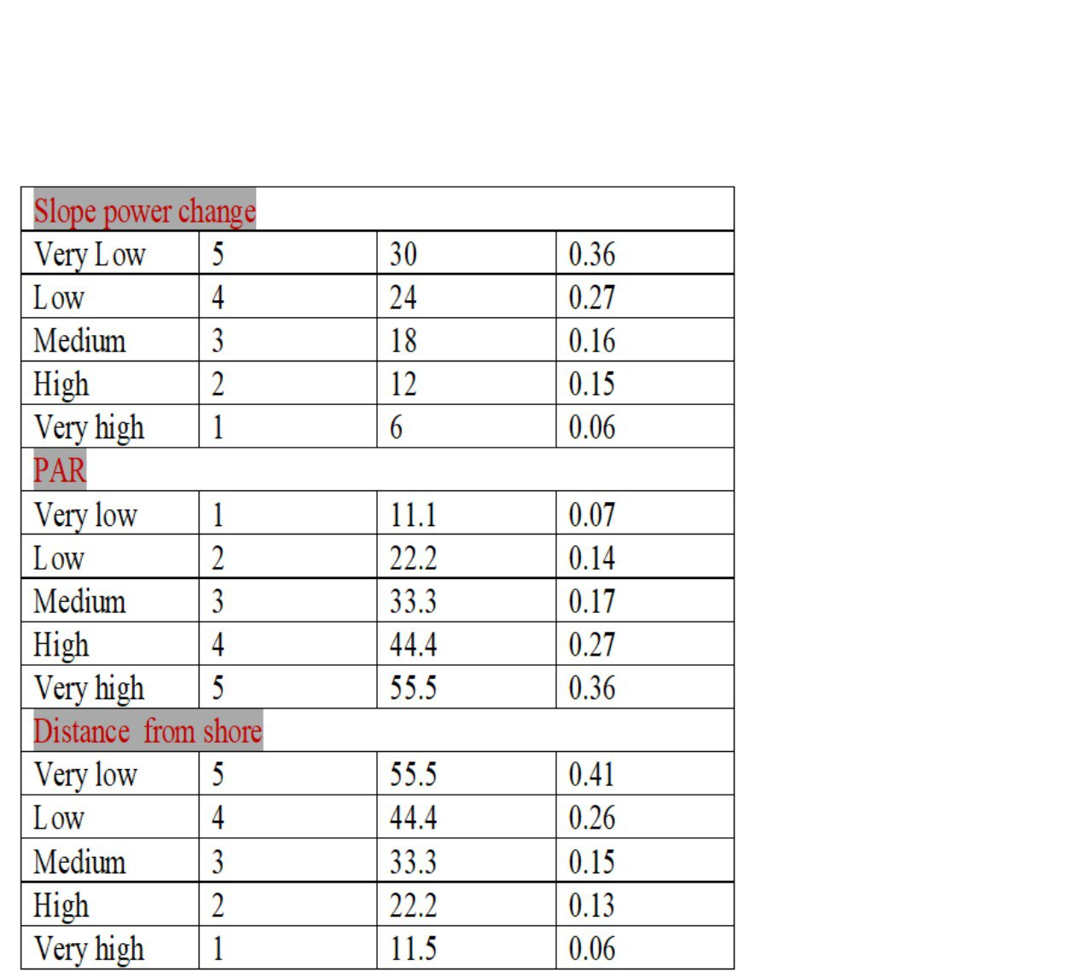

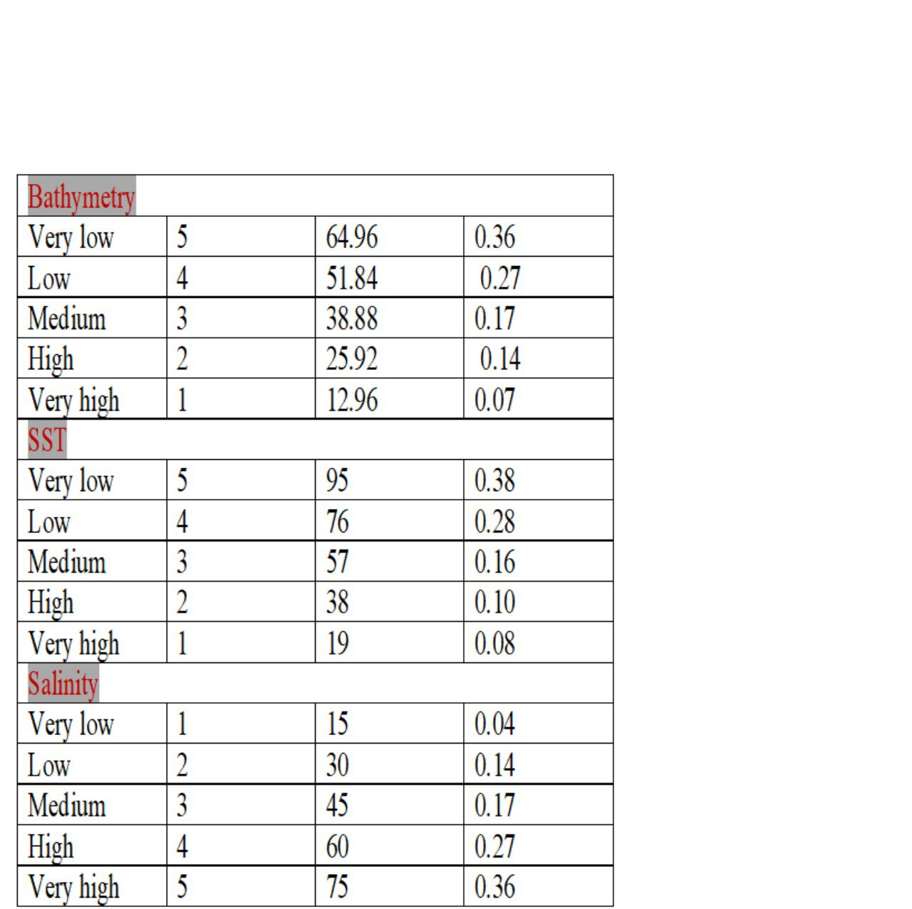

Table 3 Over all weightage and rank for AHP& MIF model

##### **5.4.1. Existing Coral Cover (ECC)**

The existing coral cover map has been prepared from Allen Coral Atlas (US) and NDWI. Very high coral cover means high coral are there and very low means less coral cover. We have assign a high weightage and rank for very highest weightage and rank for Very high coral cover region, in AHP 0.33 and in MIF 55.5 weightages assigned. Height weightage and rank assigned for high coral cover region, in AHP for 0.32 and in MIF 44.4 weightage. Medium weightage assigned for moderate coral cover region, weightage for AHP & MIF for 0.16 and 33.3. low weightage and rank assigned for low coral cover region, weightage for AHP and MIF is 0.12 and 22.2. And very low weightages and rank assigned for very low coral cover region.

##### **5.4.2. Population Density (PD)**

The population density map prepared from CIESIN-GPW 411 (Gridded Population of the World) using Google Earth Engine. We classify into five classes like Very high, High, Medium, Low and Very low. Population density means number of Person per square kilometer. Very High population density means this region covered by high population and very low population density means very low population or no population density. We assigned a Very high weightage and rank for less population density, very high population density assigned a low weightage for AHP& MIF is 0.06 and 5.6. Assigned Very high weightage for Very low population density in AHP & MIF are 0.36 and 28.

##### **5.4.3. Chlorophyll-a Concentration (CC)**

Chlorophyll-a concentration map prepared from NASA ocean color (MODIS-Aqua). We classified into five classes like Very high, high, medium, low a very low. We assigned very high weightage for very high chlorophyll-a concentration and very low weightage for very low concentration. Assigned a very high weightage for both AHP&MIF model is 0.36 and 45 for high chlorophyll-a concentration. High weightage for High chlorophyll-a concentration both AHP& MIF models is 0.27 and 36. Moderate chlorophyll-a concentration has a medium weightage for both AHP& MIF models 0.16 and 27. Low chlorophyll-a concentration assigned a low weightage for both models AHP & MIF 0.15 and 27. Very low weightage assigned for very low chlorophyll-a concentration are 0.06 for AHP model and 9 for MIF model

##### **5.4.4. Slope**

Slope Power Change map prepared from HYCOM using google earth engine. We classified into five classes like very low slope and low, medium, high and very high slope. Assigned a high weightage for both AHP& MIF model is very low slope 0.36 and 30. High weightage for low slope 0.27 and 24, moderate weightage for medium slope o0.16 and 18, Low weightage for High slope 0.15 and 12 And very low weightage for very high slope is 0.06 and 6.

##### **5.4.5. Photosynthetically Available Radiation (PAR)**

PAR map prepared from NASA ocean color data. We have classified into five classes like very high, high, medium, low and very low. Assigned a very high weightage for both susceptibility models AHP & MIF is very high PAR is 0.36 and 55.5, high weightage assigned for high concentration of par is 0.27 and 44.4, moderate weightage assigned for medium PAR concentration 0.17 and 33.3, low weightage assigned for low PAR concentration 0.14 and 22.2 and very low weightage assigned for very low PAR concentration 0.07 and 11.1.

##### **5.4.6. Distance from Shore (DFS)**

##### Distance from shore map was prepared from Andaman Island boundary. We classified into five classes like very low, low, medium, high, and very high. Assigned a high weightage for very low DFS or near to the shore in both susceptibility models AHP & MIF 0.41 and 55.5, high weightage for low DFS in both models 0.26 & 44.4, moderate weightage assigned for medium DFS 0.15 and 33.3, low weightage assigned by high DFS 0.13 and 22.2 and very low weightage assigned for very high DFS 0.06 and 11.5.

##### **5.4.7. Bathymetry**

Bathymetry map was prepared from HYCOM sea surface elevation. Then we assigned a weightage for 2005, 2010 and 2015 and average for both AHP & MIF models. We classified into five classed like very high, high, medium, low and very low, assigned very high weightage for both AHP & MIF very low bathymetry 0.36 and 64.96, high weightage for low bathymetry 0.27 & 51.84, moderate weightage assigned for moderate bathymetry 0.17 and 38.8, low weightage for high bathymetry 0.14 and 25.92 and very low weightage assigned for very high bathymetry 0.07 and 12.96.

##### **5.4.8. Sea Surface Temperature (SST)**

Sea Surface Temperature map prepared from NASA ocean colour data (MODIS-Aqua). The SST was classified into five classes like very low SST, low SST, medium SST, high SST and very high SST. Assigned a weightage for 2005, 2010 and 2015 and average for both AHP & MIF models. Assigned a very high weightage for very low SST in both AHP & MIF models are 0.38, 95, high weightage for low SST 0.28 and 76, medium weightage for moderate SST is 0.16 and 57, low weightage assigned for high SST 0.10 and 38 and very low weightages assigned for very high SST is 0.08 and 19.

##### **5.4.9. Salinity**

Salinity map was prepared from HYCOM (hybrid). Salinity was classified into five classes like very high, high, medium, low and very low. Assigned a weightage for 2005, 2010 and 2015 and average for both AHP & MIF models. Assigned a high weightage for high salinity and low weightage for very low salinity. In both AHP&MIF models weightages are very high weightage for very high salinity 0.36 and 75, high weightage for high salinity 0.27 and 60, medium weightage for moderate salinity both model 0.17 and 45, low salinity assigned a low weightage for both models 0.14 and 30, very low weightage assigned for very low salinity the weightages are 0.04 and 15.

##### **5.5.1. Susceptibility Model-1 AHP**

**AHP inputs**

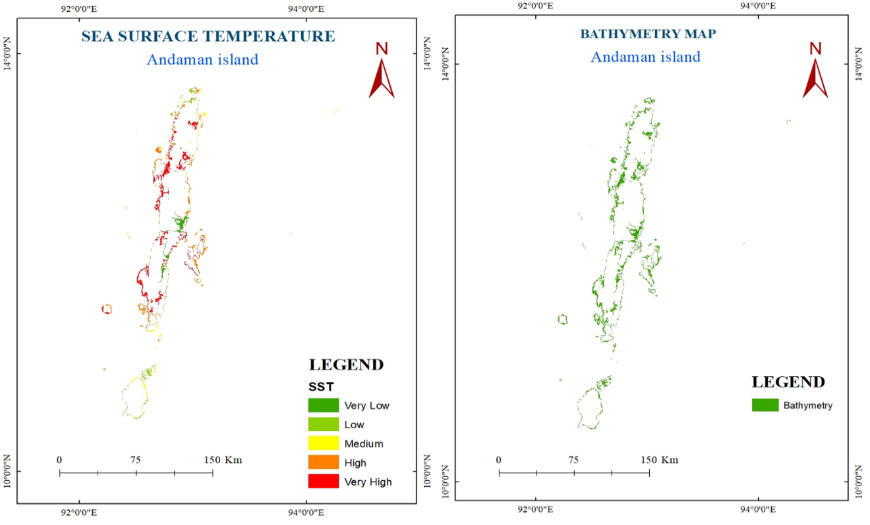

Figure 34 spatial variation for SST & Bathymetry

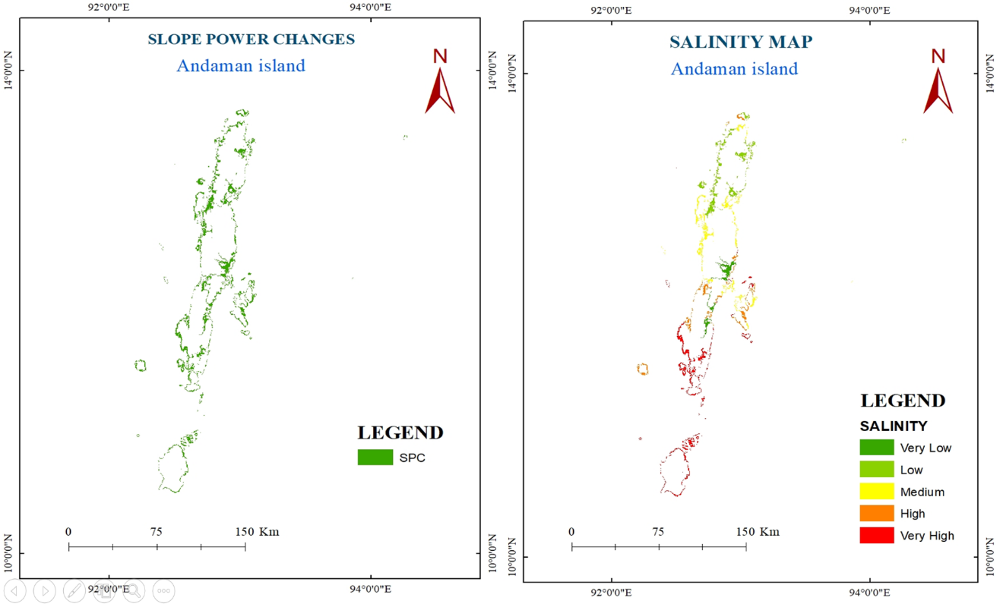

Figure 35 spatial variation for Slope, salinity

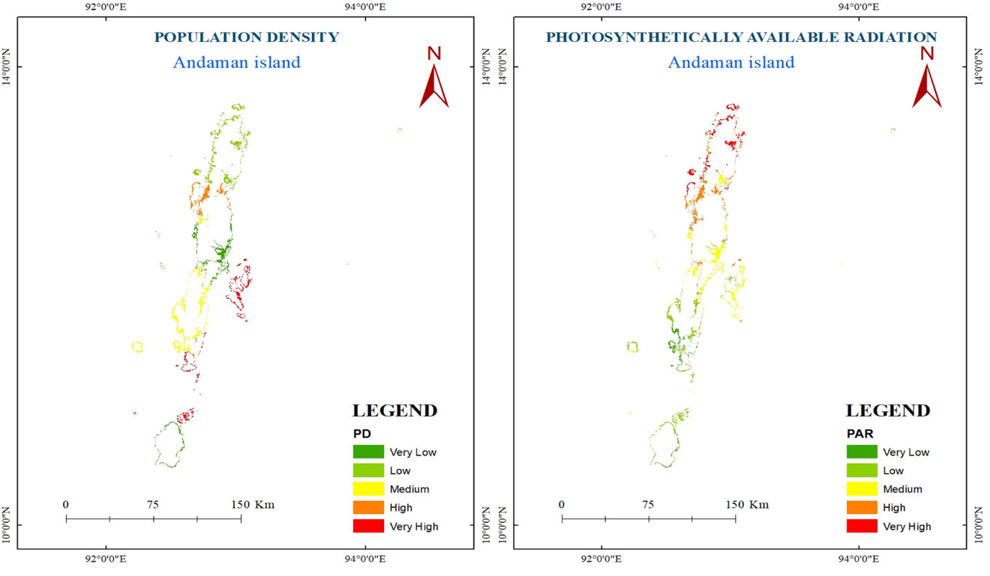

Figure 36 spatial variation for PD&PAR

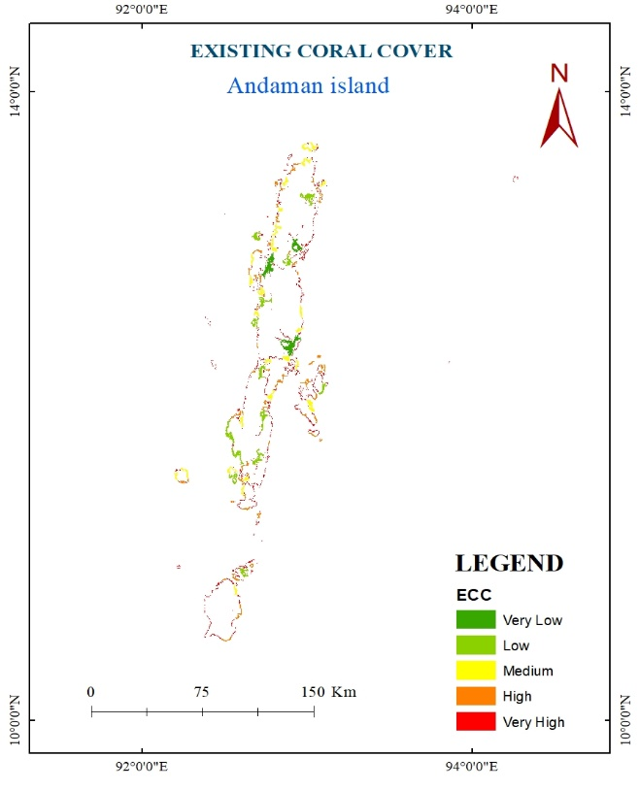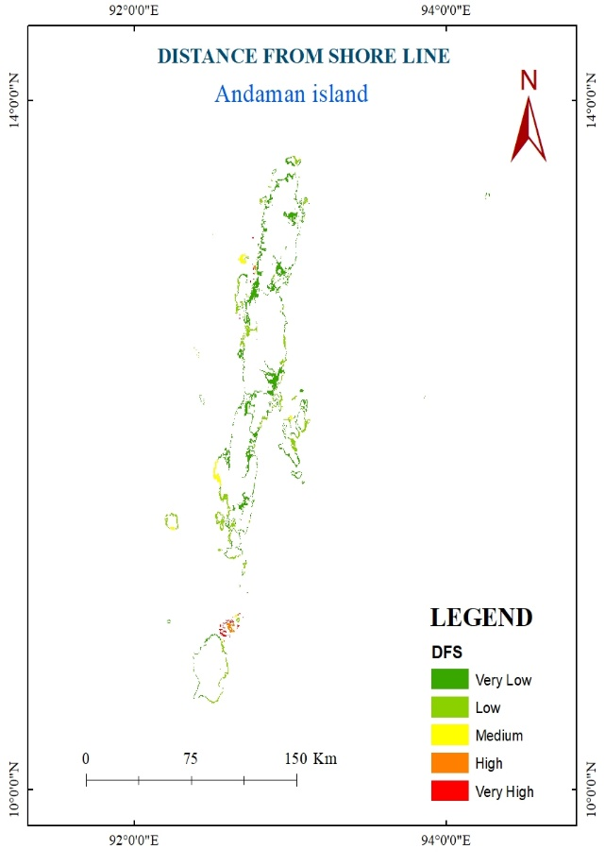

Figure 37 spatial variation for ECC& DFS

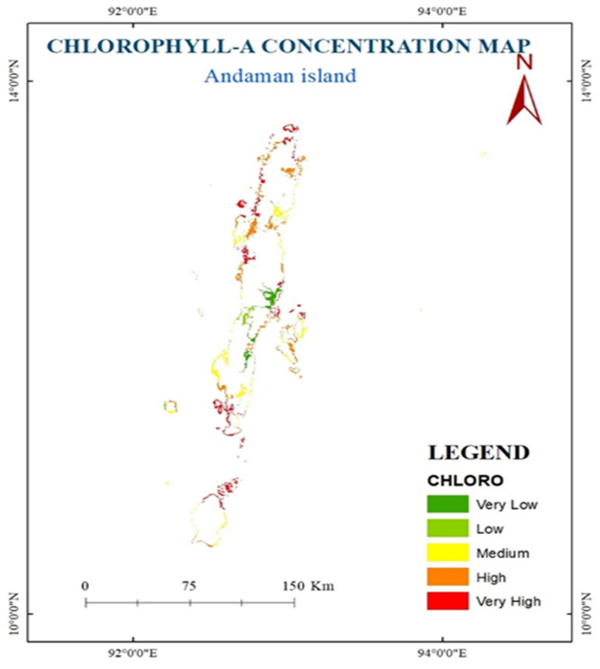

Figure 38 spatial variation for Chlorophyll-a

The above mentioned maps are used as the input for AHP method. Weightage for each map are assigned as shown in AHP weightage table and the outputs are taken for year 2005,2010,2015 and average of year 2005 to 2015. The outputs which are derived from AHP method are shown below.

**AHP output**

**Coral Bleaching Vulnerability Index Map for 2005**

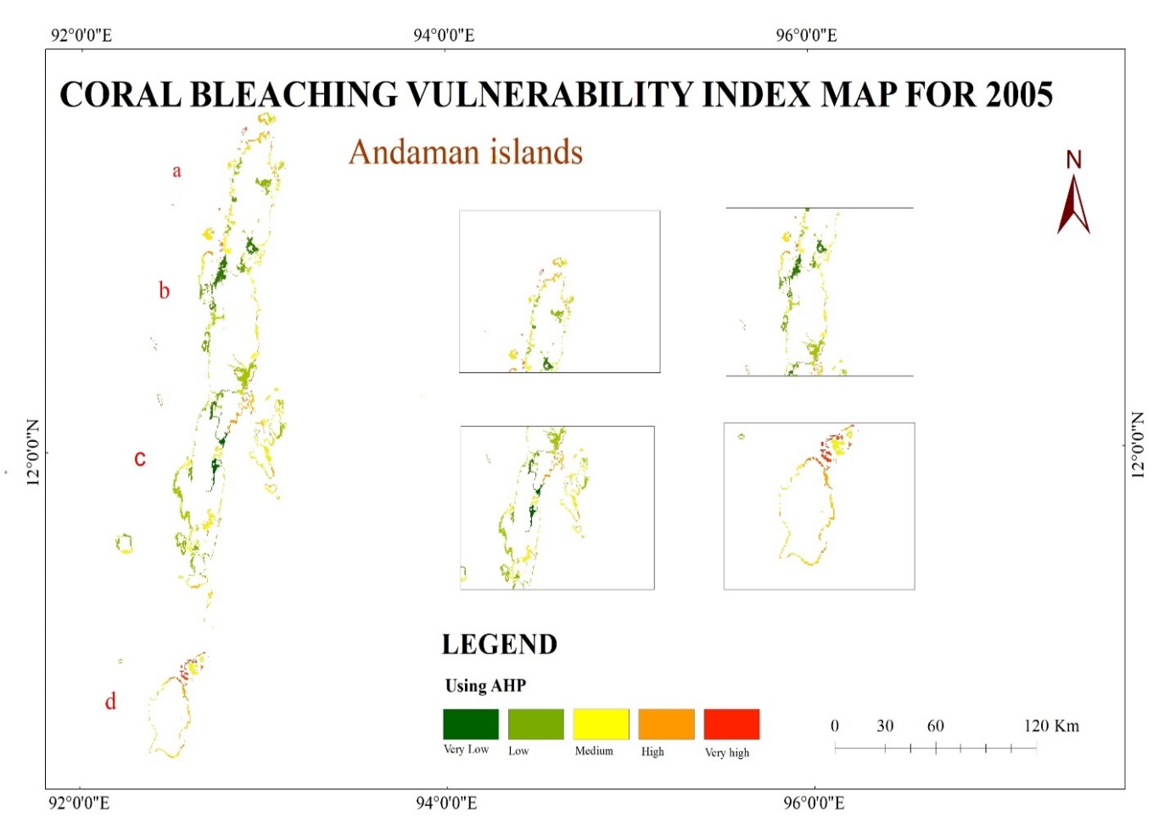

Figure 39 Vulnerability index map using AHP 2005

In AHP Model result of year 2005 shows that Southern side is very high vulnerable zone for coral bleaching compared to North side. Very Healthy corals are 0.25% and Healthy corals are 0.12%, Moderately bleached corals are 0.18%, Bleached corals are 71,77% and dead corals are 26.67%.

**Coral Bleaching Vulnerability Index Map for 2010**

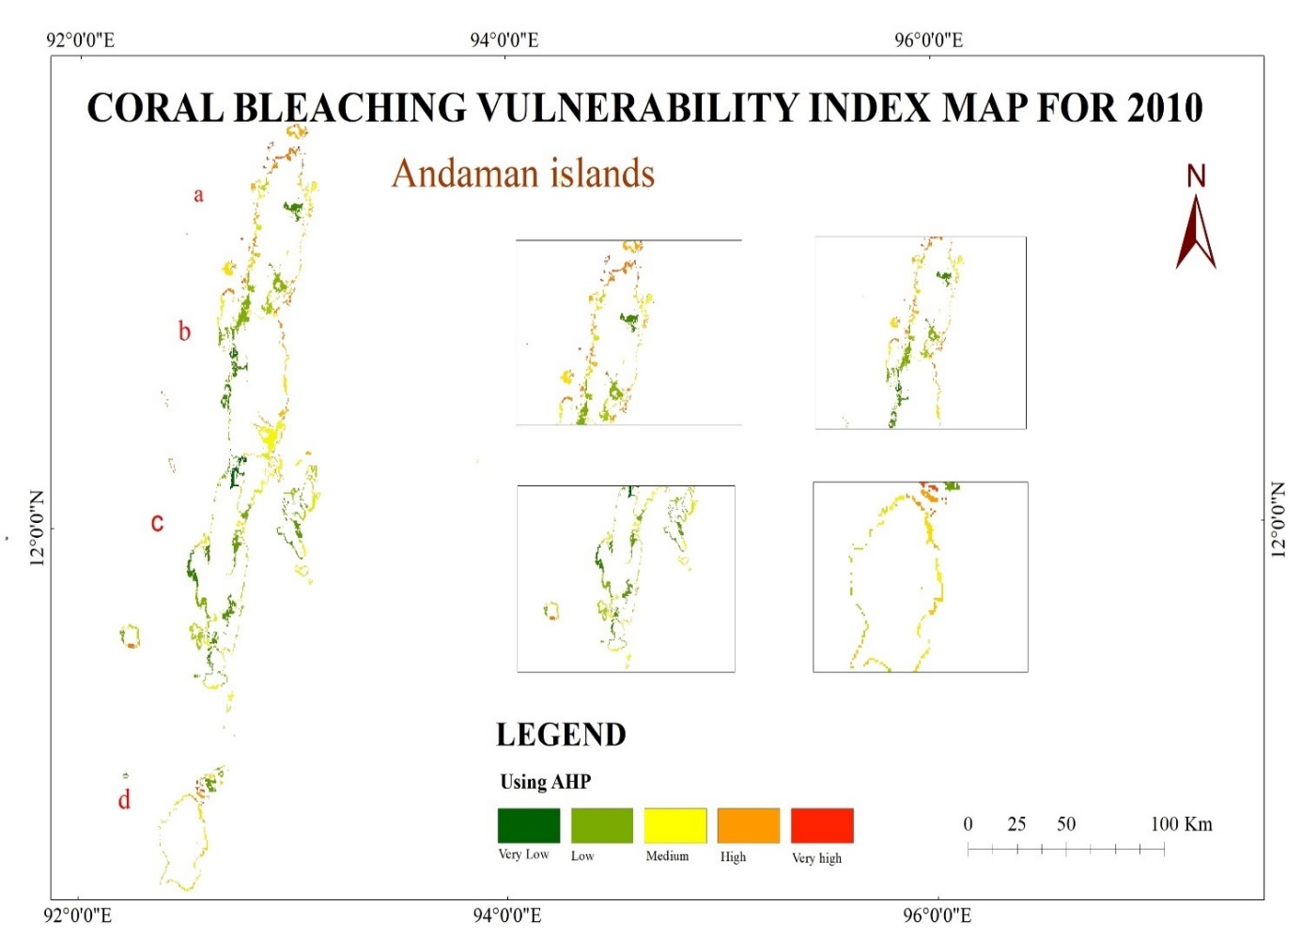

Figure 40 vulnerability index map using AHP 2010

In 2010 little Andaman is high vulnerable zone. Very healthy corals are 17.13%, healthy corals 27.44%, moderately bleached corals are 25.71%, bleached corals are 19.84% and dead corals are 10.43%.

**Coral Bleaching Vulnerability Index Map for 2015**

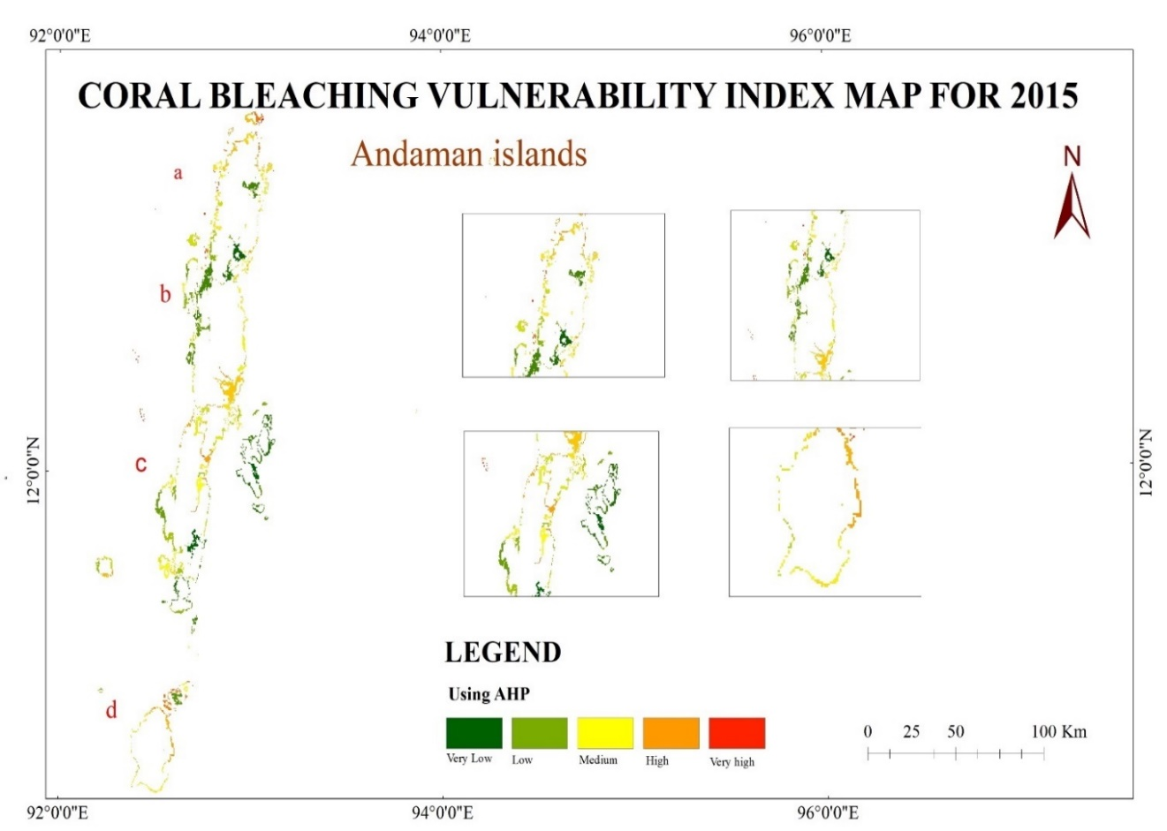

Figure 41 vulnerability index map using AHP 2015

In 2015 eastern side is more vulnerable compared to western side. Very healthy corals are 18.81%, healthy corals 19.71%, moderately bleached corals 31.05%, bleached corals 25.89% and dead corals5.02%. Between 2005 to 2015 using AHP model the recovery corals is gradually increasing, dead corals are gradually decreasing.

**Coral Bleaching Vulnerability Index Map – Avg. 2005 to 2015**

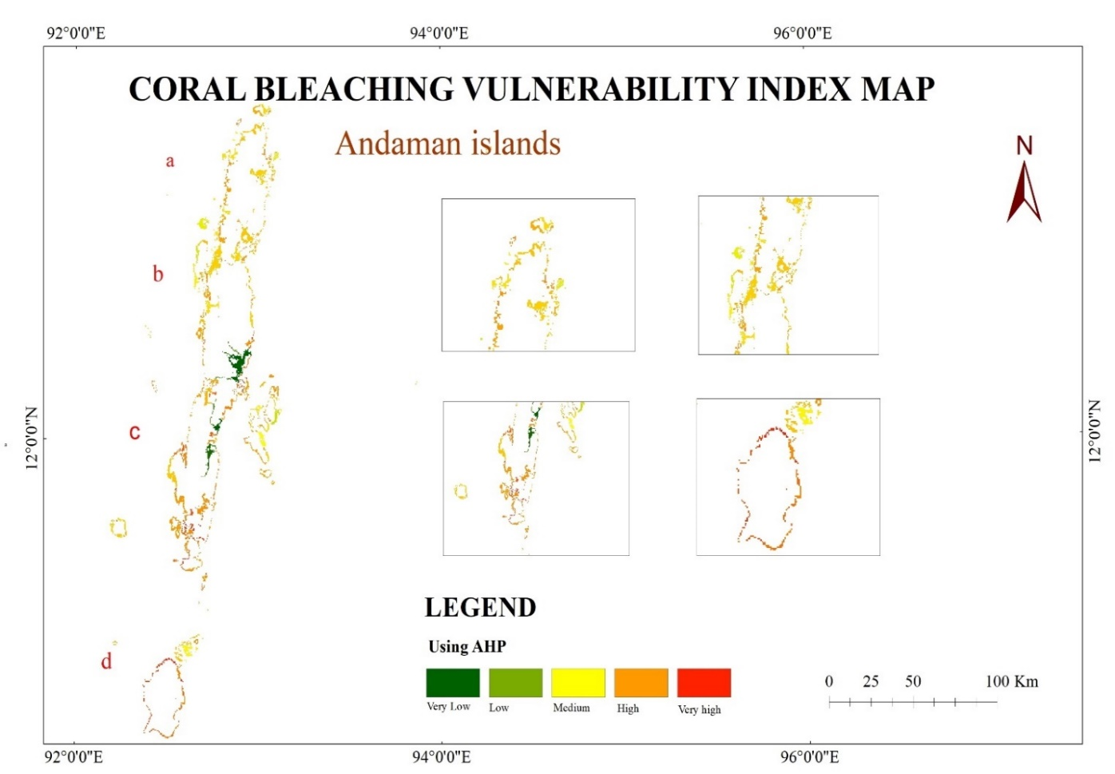

Figure 42 Vulnerability Index map using AHP

The overall AHP for year 2005 – 2015 shows that southern side is of completely bleached corals. The very healthy corals are 6.05%, healthy corals 25.77%, Moderately bleached corals 35.04%, bleached corals is 23.6% and dead corals is 9.53%.

##### **5.5.2. Susceptibility Model 2 -MIF**

**MIF Input**

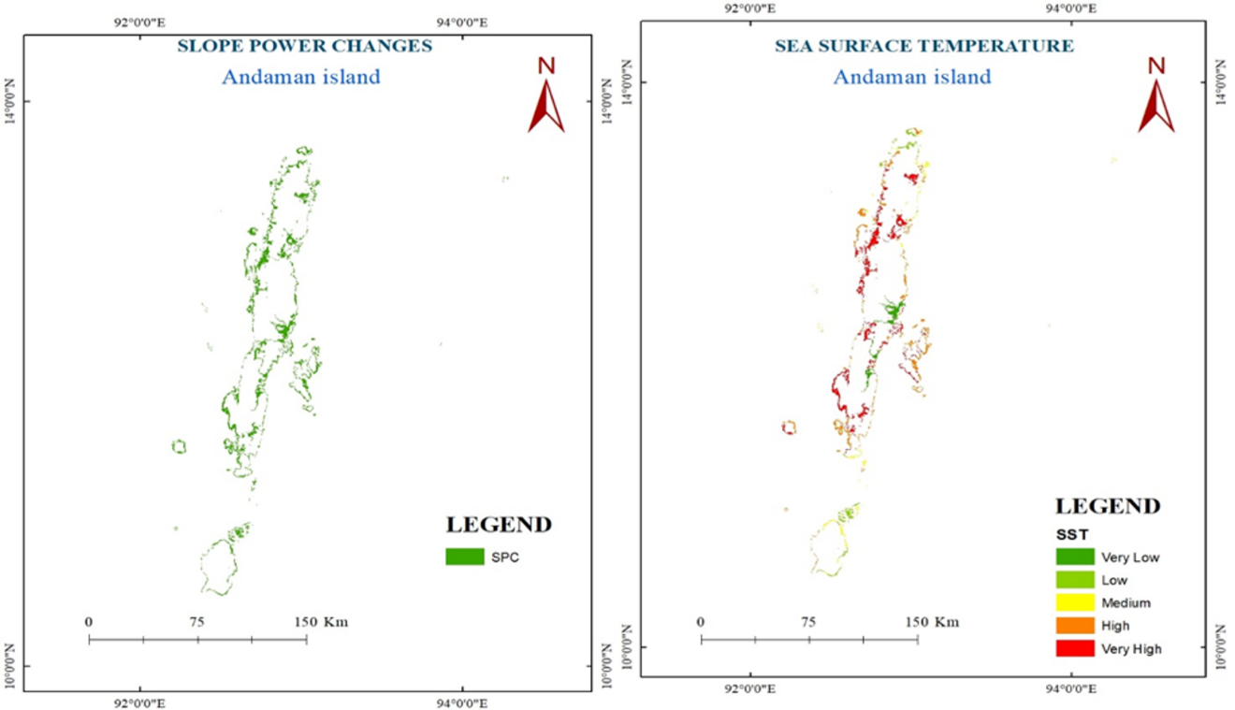

Figure 43 spatial variation for Slope &SST

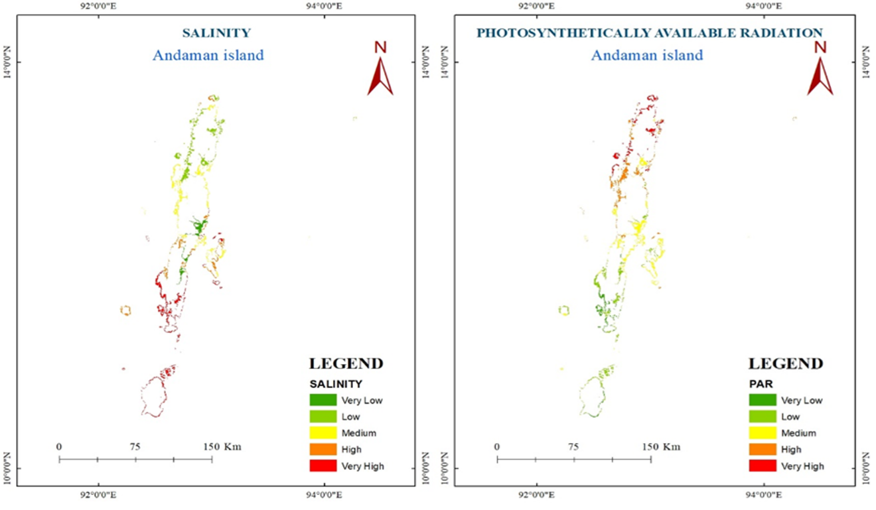

Figure 44 spatial variation for Salinity y& PAR

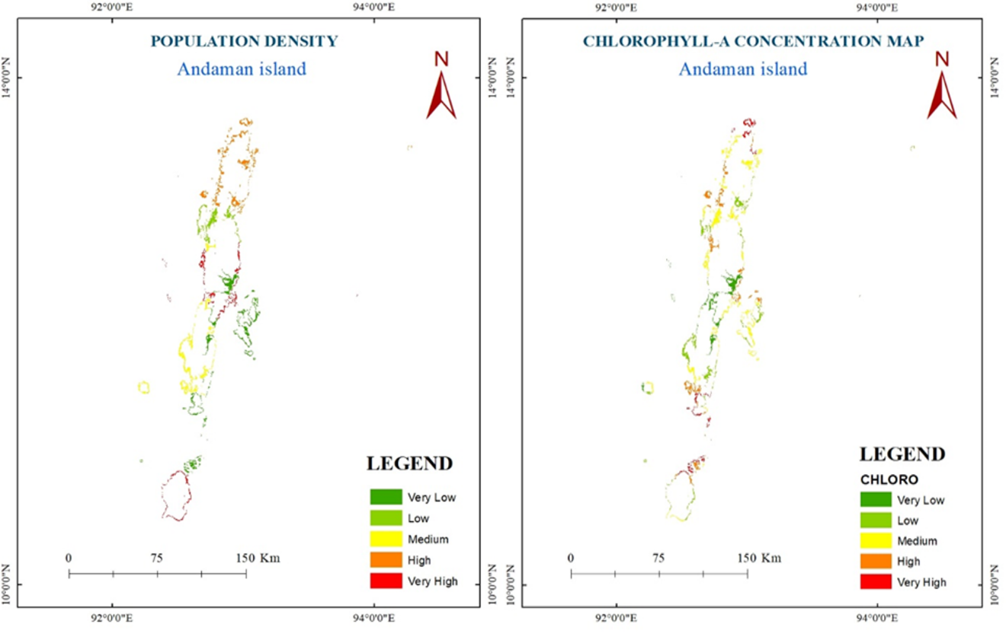

Figure 45 spatial variation for PD& chlorophyll-a

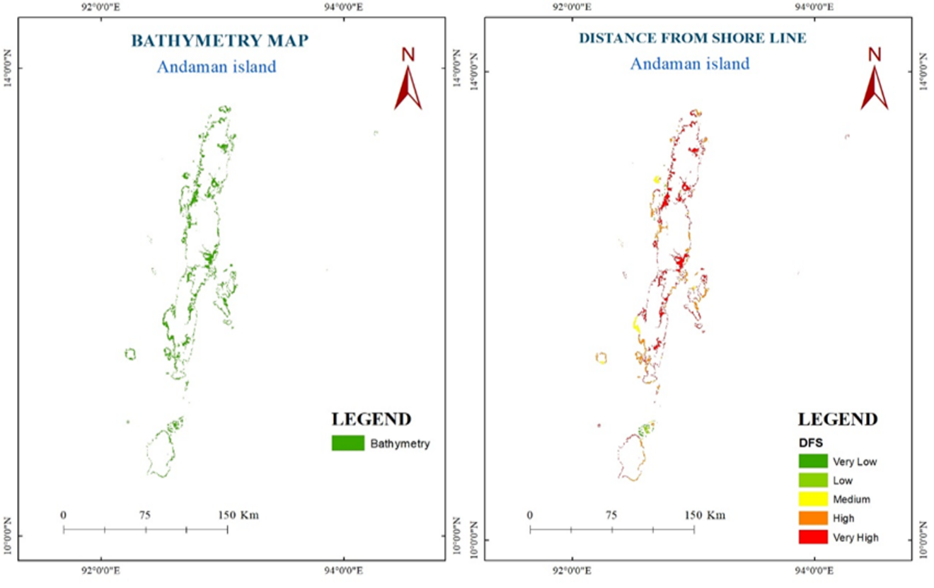

Figure 46 spatial variation for Bathymetry & DFS

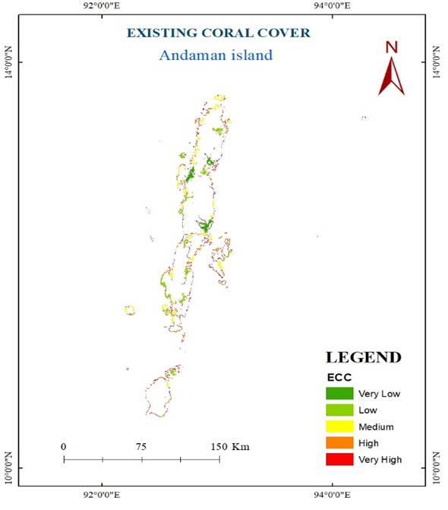

Figure 47 Existing coral cover for Andaman region

The above mentioned maps are used as the input for MIF method. Weightage for each maps are assigned as shown in MIF weightage table and the outputs are taken for year 2005, 2010, 2015 and average of year 2005 to 2015. The outputs which are derived from MIF method are shown below.

**MIF Output**

**Coral Bleaching Vulnerability Index Map for 2005**

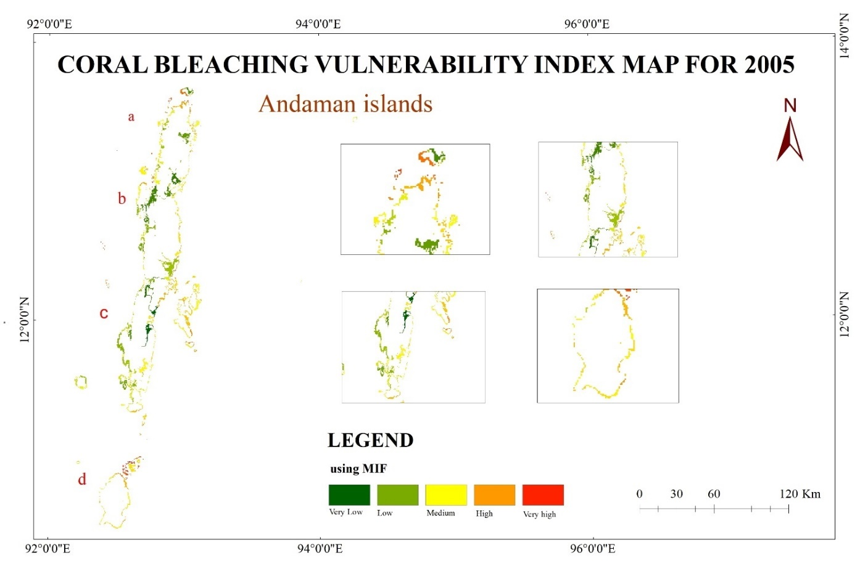

Figure 48 vulnerability index map using MIF 2005

In Multi influencing factor model for 2005 Western side is more vulnerable and eastern side is less vulnerable. The very healthy corals are 0.25%, healthy corals are 0.13%, moderately bleached corals are 3.75%, bleached corals 61.74% and dead corals are 34.11%.

**Coral Bleaching Vulnerability Index Map for 2010**

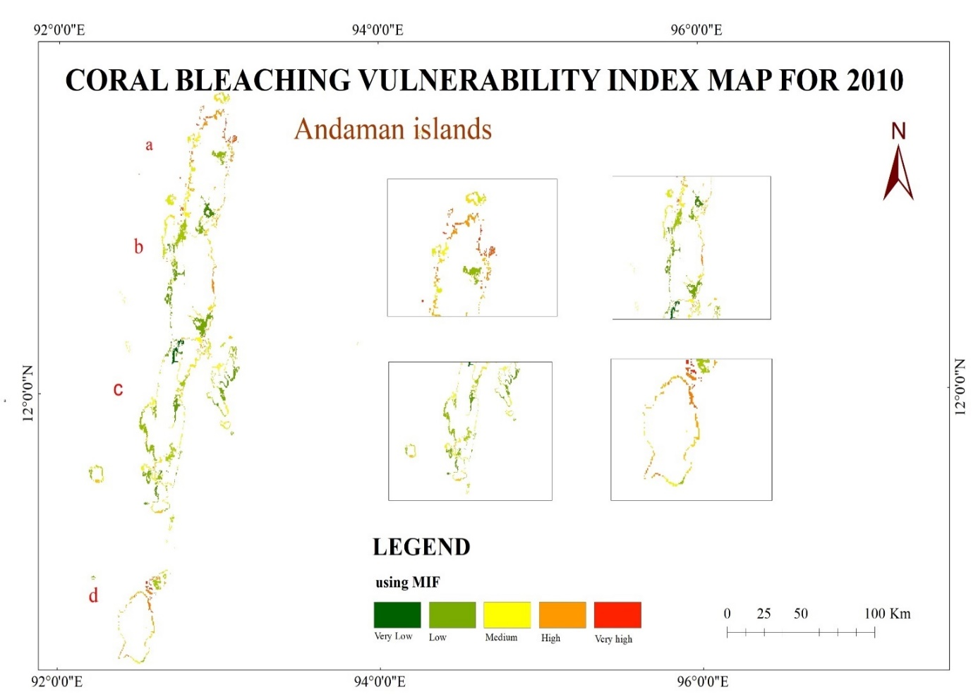

Figure 49 vulnerability index map using MIF 2010

In 2010 very healthy corals are 10.82%, healthy corals 23.32%, moderately bleached corals 30.15%, bleached corals 24.71% and dead corals are 11.45%.

**Coral Bleaching Vulnerability Index Map for 2015**

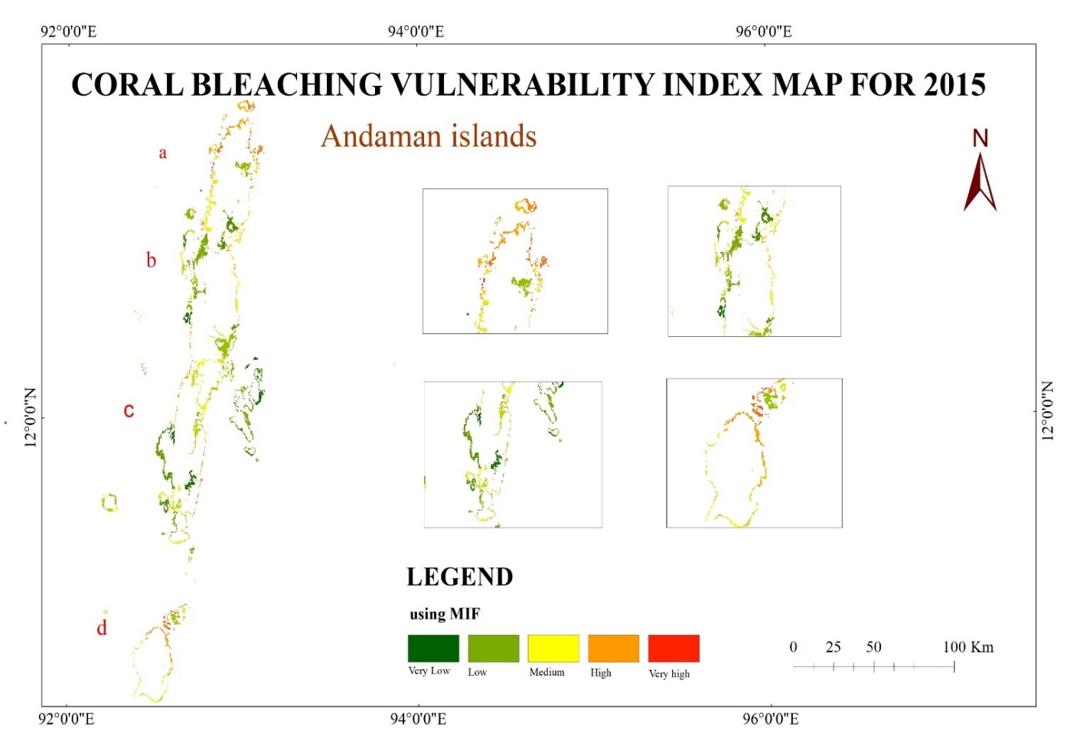

Figure 50 vulnerability index map using MIF 2015

In 2015 Very healthy corals are 16.36%, healthy corals 31.18%, moderately bleached corals 22.67%, bleached corals is 22.29% and dead corals are 7.98%.

**Coral Bleaching Vulnerability Index Map – Avg. 2005 to 2015**

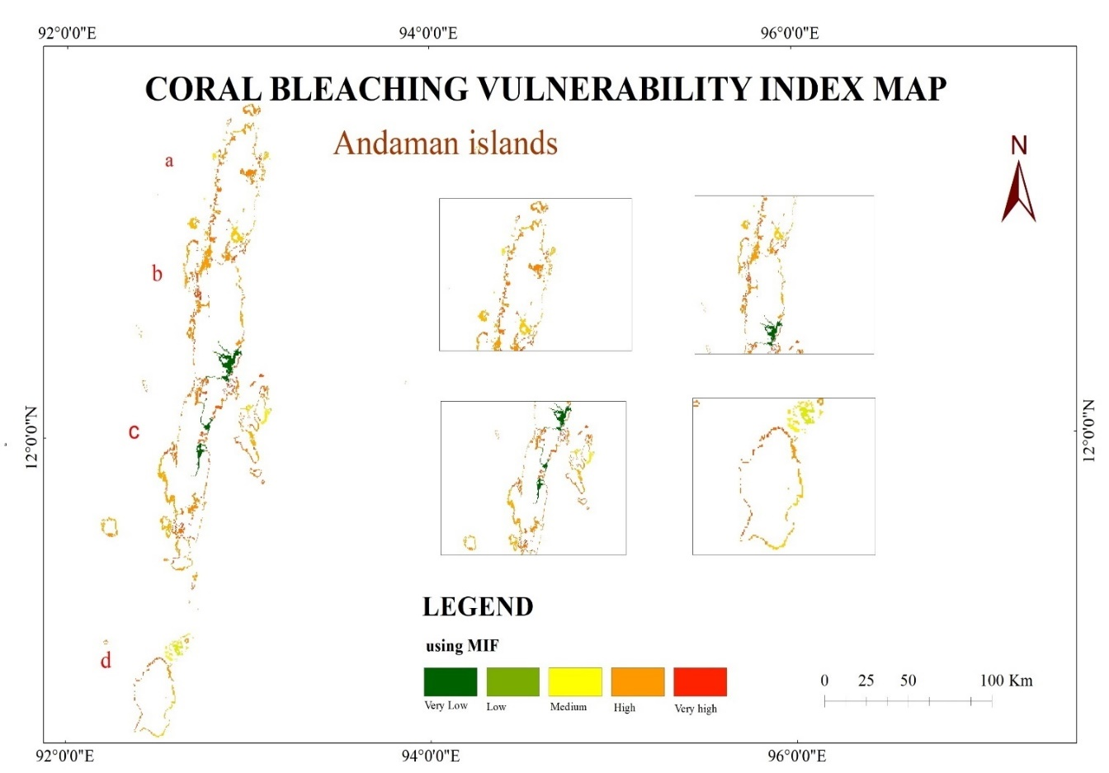

Figure 51 vulnerability index map using MIF

Very healthy corals are 6.31%, healthy corals 13.04%, moderately bleached corals 28.6%, bleached corals 34.8% and dead corals 17.3%. In MIF model also the healthy coral is gradually increased from 2005 to 2015 and dead corals have been gradually decreased.

The coral bleaching is not permanent event its temporary event. After the summer season the ocean is cool due to climate change the corals are bleached corals is recover.

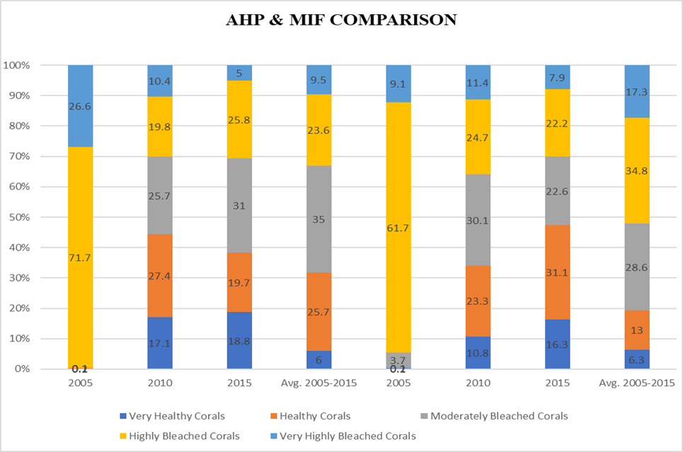

Figure 52 comparison of AHP & MIF model results

##### **5.6. FUTURE PREDICTION FOR CORAL BLEACHING VULNERABLE ZONE**

Future prediction for 2045. This future prediction was prepared using Both susceptibility model results using QGIS 2.16.1. We added raster data of 2005 and 2010 coral bleaching vulnerable zones map and changed the single band pseudo colour and changed the normal mode into equal interval. We used the MOLUSCE plugin to get the prediction map. First we used initial year as 2005 and final year as 2010, then we added the spatial variations: Bathymetry and SST-to check the geometry error. Next we used the Pearson’s correlation to calculate the area- to update the table- create changes map. Transition Potential modelling- create the train- cellular automate simulation- ad the validation data using 2025. To predict the 2015 vulnerability map. Using this 2025 map we created 2035 changes vulnerable map. Using 2035 map we created the 2045 possible vulnerable zone.

Prediction of Coral Bleaching Vulnerability Index for 2045 using Susceptibility Model 1 AHP indicates that most of the area is high vulnerable zone. Which is indicated in red to orange colour, green colour is possible for low vulnerable zone. Most of the area is covered by yellow colour which is indicates moderately vulnerable zone. The eastern side is fully covered by High and moderate coral bleaching vulnerable zone, the western side is low vulnerable zone compare to eastern side. The north Andaman is fully covered by high and moderate vulnerable zone, which is show in figure a, middle Andaman covered by moderate and low vulnerable for coral bleaching, in middle Andaman is west side is covered by low and eastern side is covered by high and moderate vulnerable zone. In north Andaman and the sentinel island is covered by moderate bleaching vulnerable zone. The little Andaman is covered by high and medium bleaching vulnerable zone.

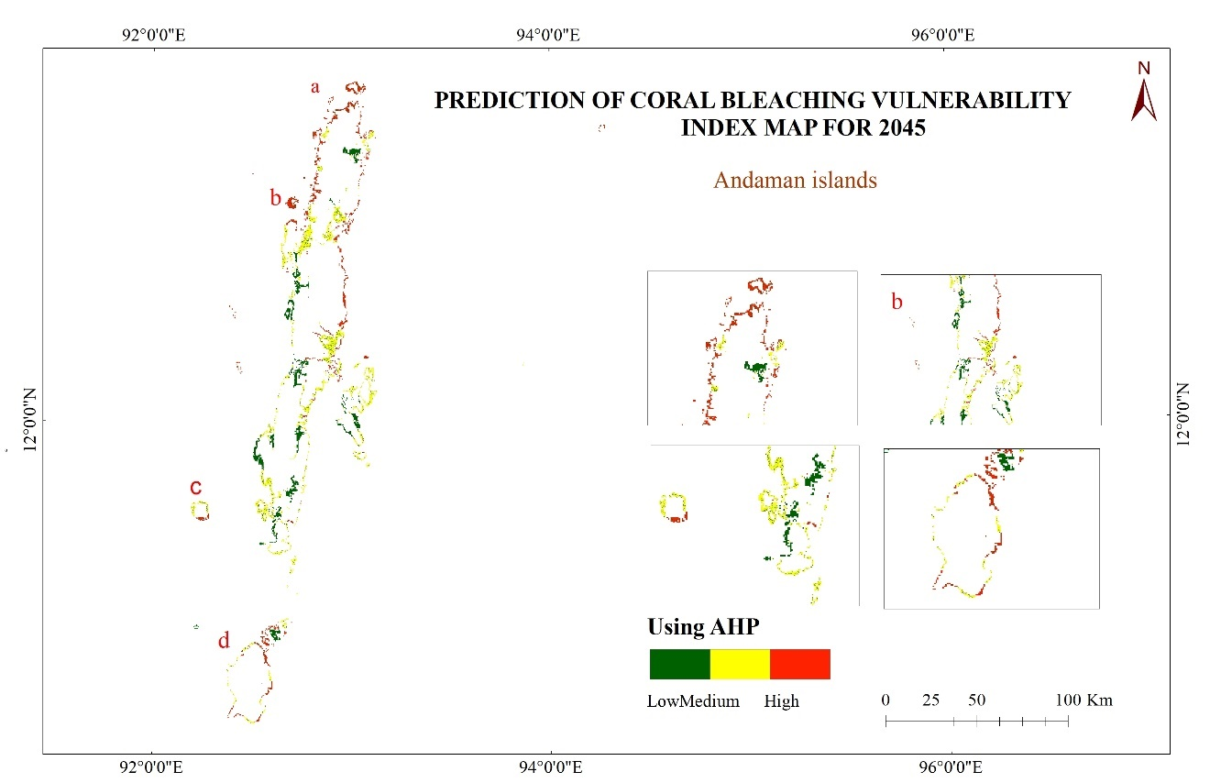

Figure 53 Future prediction map for 2045 using AHP

Prediction of 2045 coral bleaching vulnerable zone using susceptibility model 2 MIF shows that most of the area is covered by low vulnerable zone and medium and low vulnerable zone and high vulnerable zone covers very less area. The North Andaman partially covered by high and medium vulnerable zone.

Middle Andaman’s western side is low vulnerable zone, and east side is partially low, high and medium vulnerable zone. The eastern side of Andaman region is high vulnerable when compare to western side. Sentinel island is low coral bleaching vulnerable zone. The little Andaman is high vulnerable zone is of low vulnerable zone because of possible Sea Surface Temperature and Salinity variations. The figure a is shows the north Andaman and b is shows the middle Andaman and c is shows the north sentinel island and south Andaman and d is shows the little Andaman.

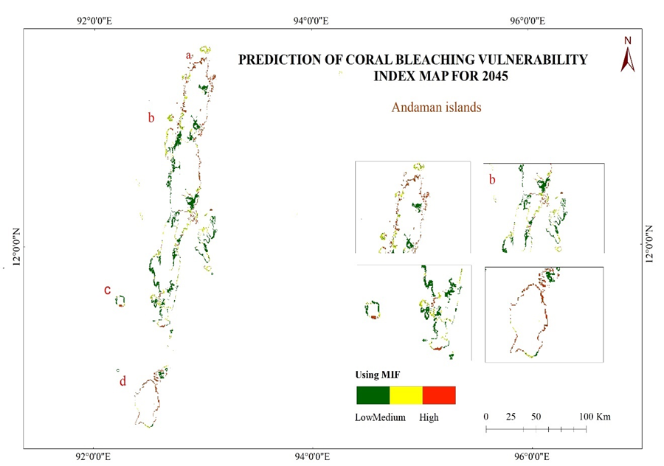

Figure 54 Future prediction map for 2045 using MIF

In both AHP and MIF western side is less vulnerable compared to eastern side. And the south side is more vulnerable compared to north side because north side has high fresh water mixing and its near to the pole compare to southern side. The south side is near to the equator and due to the effect el Nino, south side is more vulnerable.

###### **6. CONCLUSION**

Through this study we have identified the amount of healthy corals and bleached corals during the year 2005 -2015 using AHP & MIF methods. We used MODIS, HYCOM and CISEN data sets for this work. We used SST, salinity, bathymetry, photosynthetically available radiation, distance from shore data as main parameters and existing coral cover, population density, slope and chlorophyll concentration data as additional parameters in both AHP & MIF processing. Through these process, the coral bleaching amount was identified. As the SST and salinity are mostly higher in the southern region than the northern region, the corals in the southern region are mostly vulnerable. Discharge of freshwater from the river (e g. Ganga, Brahmaputra) the salinity is lesser in the northern part of Andaman Island. Also the human population is also high in southern part of Andaman, so the pollution caused by human activities are also high in the southern region. In the year 2005 the healthy corals rate is very low. It is due to the tsunami occurred in 2004, so the healthy coral percent was very low as 0.13%. The results from AHP & MIF process have been classified into five classes as very healthy corals, healthy corals, moderately bleached corals, bleached corals and dead corals. As we have used two methods the total number coral bleaching vulnerability index map is eight. They are for the year 2005, 2010, 2015 and average of 2005 – 2015. By AHP process we delineated; in 2005 very healthy corals are 0.25% - healthy corals are 0.12% - moderately bleached corals are 0.18% - bleached corals are 71.77% - dead corals are 26.67%. In 2010 very healthy corals are 17.13% - healthy corals are 27.4% - moderately bleached corals are 25.71% - bleached corals are 19.84% - dead corals are 10.43%. In 2015 very healthy corals are 18.81% - healthy corals are 19.71% - moderately bleached corals are 31.05% - bleached corals are 25.89% - dead corals are 5.02%. Average between 2005 – 2015 very healthy corals are 6.05% - healthy corals are 25.77% - moderately bleached corals are 35.04% - bleached corals are 23.6% - dead corals are 9.53%. By MIF process we delineated; in 2005 very healthy corals are 0.25% - healthy corals are 0.13% - moderately bleached corals are 3.75% - bleached corals are 3.75% - dead corals are 9.14%. In 2010 very healthy corals are 10.82% - healthy corals are 23.32% - moderately bleached corals are 30.15% - bleached corals are 24.71% - dead corals are 11.45%. In 2015 very healthy corals are 16.36% - healthy corals are 31.18% - moderately bleached corals are 22.67% - bleached corals are 22.29% - dead corals are 7.98%. Average between 2005 – 2015 very healthy corals are 6.31% - healthy corals are 13.04% - moderately bleached corals are 28.6% - bleached corals are 34.8% - dead corals are 17.13%. By comparing all these results we can conclude that the southern and western part of Andaman Island is more vulnerable to bleaching. We have also identified the future coral bleaching susceptibility using the CA Markov algorithm using QGIS software for the year 2045.

**7. REFERENCE**

*Aburas, Maher Milad, Sabrina Ho Abdullah, Mohammad Firuz Ramli, and Zulfa Hanan. 2015. “A Review of Land Suitability Analysis for Urban Growth by Using the GIS-Based Analytic Hierarchy Process.” Asian Journal of Applied Sciences 03 (06): 869–76.*

*Aithal, Bharath H., and T. V. Ramachandra. 2016. “Visualization of Urban Growth Pattern in Chennai Using Geoinformatics and Spatial Metrics.” Journal of the Indian Society of Remote Sensing 44 (4): 617–33. https://doi.org/10.1007/s12524-015-0482-0.*

*Aliani, Hamide, Mohadeseh Ghanbari Motlagh, Ghazaleh Danesh, and Hamed Aliani. 2021. “Land Suitability Analysis for Urban Development Using TOPSIS, WLC and ANP Techniques (Eastern Cities of Gilan-Iran).” Arabian Journal of Geosciences 14 (13). https://doi.org/10.1007/s12517-021-07606-1.*

*Bagheri, Milad, Wan Nor Azmin Sulaiman, and Negin Vaghefi. 2013. “Application of Geographic Information System Technique and Analytical Hierarchy Process Model for Land-Use Suitability Analysis on Coastal Area.” Journal of Coastal Conservation 17 (1): 1–10. https://doi.org/10.1007/s11852-012-0213-4.*

*Chandio, Imtiaz Ahmed, Abdul Nasir Matori, Dano Umar Lawal, and Soheil Sabri. 2011. “GIS-Based Land Suitability Analysis Using AHP for Public Parks Planning in Larkana City.” Modern Applied Science 5 (4): 177–89. https://doi.org/10.5539/mas.v5n4p177.*

*Jafari, Sudabe, and Narges Zaredar. 2010. “Land Suitability Analysis Using Multi Attribute.” International Journal of Environmental Science and Development 1 (5): 441–45.*

*Jamil, Mubashir, Raihan Ahmed, and Haroon Sajjad. 2018. “Land Suitability Assessment for Sugarcane Cultivation in Bijnor District, India Using Geographic Information System and Fuzzy Analytical Hierarchy Process.” GeoJournal 83 (3): 595–611. https://doi.org/10.1007/s10708-017-9788-5.*

*KUMAR, Manish, and Vivekananda BISWAS. 2013. “Identification of Potential Sites for Urban Development Using GIS Based Multi Criteria Evaluation Technique . A Case Study of Shimla Municipal Area , Shimla District ,.” Journal of Settlements and Spatial Planning 4 (August): 45–51.*

*Kumar, Manish, and Vasim Riyasat Shaikh. 2013. “Site Suitability Analysis for Urban Development Using GIS Based Multicriteria Evaluation Technique: A Case Study of Mussoorie Municipal Area, Dehradun District, Uttarakhand, India.” Journal of the Indian Society of Remote Sensing 41 (2): 417–24. https://doi.org/10.1007/s12524-012-0221-8.*

*Murgante, Beniamino, and Giuseppe Las Casas. 2004. “G.I.S. and Fuzzy Sets for the Land Suitability Analysis.” Lecture Notes in Computer Science (Including Subseries Lecture Notes in Artificial Intelligence and Lecture Notes in Bioinformatics) 3044: 1036–45. https://doi.org/10.1007/978-3-540-24709-8_109.*

*Park, Soyoung, Seongwoo Jeon, Shinyup Kim, and Chuluong Choi. 2011. “Prediction and Comparison of Urban Growth by Land Suitability Index Mapping Using GIS and RS in South Korea.” Landscape and Urban Planning 99 (2): 104–14. https://doi.org/10.1016/j.landurbplan.2010.09.001.*

*Parry, Jahangeer A., Showkat A. Ganaie, and M. Sultan Bhat. 2018. “GIS Based Land Suitability Analysis Using AHP Model for Urban Services Planning in Srinagar and Jammu Urban Centers of J&K, India.” Journal of Urban Management 7 (2): 46–56. https://doi.org/10.1016/j.jum.2018.05.002.*

*Yeh, Anthony Gar On, and Xia Li. 1998. “Sustainable Land Development Model for Rapid Growth Areas Using GIS.” International Journal of Geographical Information Science 12 (2): 169–89. https://doi.org/10.1080/136588198241941.*